 | MINISTRY OF EDUCATION AND TRAINING

FPT UNIVERSITY
Capstone Project Document
Premarital Counseling Platform

Group 6
Group Members | Le Nguyen Chi Bao - SE183721  Pham Nguyen Vu - SE184101  Trinh Han Hoang Long - SE183773  Chu Phan Nhat Long - SE183738
Supervisor | NGUYEN NGOC LAM

- Ho Chi Minh city, 2/2025 -
Table of Contents

Acknowledgement 4
Definition and Acronyms. 4
I. Project Introduction. 5
1. Overview.. 5
2. Product Background. 5
3. Existing Systems. 5
4. Business Opportunity. 5
5. Software Product Vision. 5
6. Project Scope & Limitations. 5
II. Project Management Plan. 6
1. Overview.. 6
2. Management Approach. 6
3. Master Schedule. 6
4. Project Organization. 6
5. Project Communication. 6
6. Configuration Management 6
III. Software Requirement Specification. 7
1. Overall Description. 7
2. User Requirements. 7
3. Functional Requirements. 7
4. Non-Functional Requirements. 7
5. Other Requirements. 7
IV. Software Design Description. 8
1. Overall Description. 8
2. System Architecture Design. 8
3. System Detailed Design. 8
4. Class Specification. 8
5. Data & Database Design. 8
V. Software Testing Documentation. 9
1. Overall Description. 9
2. Test Plan. 9
3. Test Cases. 9
4. Test Reports. 9
VI. Release Package & User Guides. 10
1. Deliverable Package. 10
2. Installation Guides. 10
3. User Manual 10
VII. Appendix. 10
1. Glossary [Optional] 10
2. References [Optional] 10
3. Others [Optional] 10

Definition and Acronyms
[Fill all the definitions, acronyms,… used within the document] in the table format as below]
Acronym | Definition
PCW | Premarital Counseling Website
AWS | Amazon Web Services
BA | Business Analysis
BR | Business Rule
ERD | Entity Relationship Diagram
GUI | Graphical User Interface
PM | Project Manager
SDD | Software Design Description
SPMP | Software Project Management Plan
SRS | Software Requirement Specification
UAT | User Acceptance Test
UC | Use Case
API | Application Program Interface

I. Project Introduction

1. Overview

1.1 Project Information
The Pre-marital Counseling Platform is an online service designed to support individuals and couples in preparing for marriage. The platform connects users with professional counselors and offers tailored advice on topics such as communication, conflict resolution, parenting, and family dynamics. The project aims to bridge the gap between relationship professionals and those seeking guidance before marriage.
-Project Name: Premarital Counseling Platform
-Project Code: SWD-727
-Group Name: Group 4

1.2 Project Team
-Team Members:
-Front-end: Pham Nguyen Vu, Trinh Han Hoang Long
-Back-end: Le Nguyen Chi Bao, Chu Phan Nhat Long
-Stakeholders:
-Relationship Professionals
-Users (Couples and Individuals)

2. Product Background
The Pre-marital Counseling Platform was conceived by a group of relationship professionals who recognized the growing demand for pre-marriage counseling. Many couples seek guidance on how to build stronger relationships but struggle to access personalized, expert advice before marriage. The platform addresses this gap, providing users with easy access to assessments, professional counseling, and self-help resources to help identify potential relationship challenges.

3. Existing Systems
- Link: https://www.marriage.com
- Description: Marriage.com is an online platform that provides relationship advice, marriage counseling resources, and therapist directories. It offers articles, quizzes, and professional services to help individuals and couples strengthen their relationships.
- System Actor: Guest, User, Therapist, Administrator
- Features:
  - Articles & Advice: A library of relationship-related articles written by experts.
  - Quizzes & Assessments: Interactive tools to help users evaluate their relationships.
  - Therapist Directory: A searchable list of professional therapists for counseling services.
  - Community Forums: A space for users to share experiences and seek advice.
  - Online Counseling: Users can book virtual therapy sessions with licensed professionals.
- Advantages:
  - Provides expert-backed relationship advice and resources.
  - Offers a convenient platform for finding and booking therapists.
  - Engages users with interactive quizzes and forums.
  - Wide reach with diverse topics covering marriage, dating, and family issues.
- Disadvantages:
  - May not replace in-person counseling for more complex cases.
  - Quality of advice varies depending on contributors.

4. Business Opportunity
Current products like Facebook or Zalo groups are mostly used by couple professional therapists. Those platforms are widespread among the youth and easy for advertisement. But in contrast, those platforms are often informal and lack personalized support. The platform positions itself as a professional, accessible, and expert-driven alternative, offering tailored guidance to couples.

5. Project Scope & Limitations
The Premarital Counseling Platform connects members with professional counselors for pre-marriage guidance and support. The platform offers the following functionalities:
- Homepage & Information Portal:
  - Introduction to the platform and its services.
  - Information on certified counselors.
  - Blog section for experience sharing, news, and relationship insights.
- User Registration & Authentication:
  - Allows users to sign up as either members or counselors.
- Premarital Assessment:
  - Users can take an assessment test to identify key areas for counseling (e.g., communication, conflict management, parenting, cultural differences, etc.).
- Counselor Search & Booking:
  - Members can search for suitable counselors based on expertise, ratings, and availability.
  - Scheduling consultations through the platform.
- Consultation Service Management:
  - Process Flow:
    - Members book counseling services.
    - Counseling sessions take place via online platforms (Google Meet, etc.).
    - Counselors record session outcomes.
    - Members provide ratings and feedback.
- Payment & Cancellation Policies:
  - Payment processing and refund management.
  - Cancellation policies for booked sessions.
- Counselor Profile & Management:
  - Counselors can manage their profiles, qualifications, consultation schedule, and fees.
  - System approval required for certain profile updates.
- Fee Structure & Revenue Management:
  - Subscription and consultation packages.
  - Commission management for counselors.
- Ratings & Feedback Management:
  - Members can rate and provide feedback on counseling sessions.
- User Profile & Booking History:
  - Members can manage their profiles and view past bookings.
- Dashboard & Reporting:
  - Insights and analytics for system administrators.
Limitations:
- Offline Support: The application requires an internet connection to function.
- Automated Counseling Feature: Does not include an AI chatbot for automated counseling; all counseling is conducted by human experts.
- Multilingual Support: The initial version only supports English, with no other language options.
- Standalone Desktop Version: No standalone desktop application; only accessible via web browsers and mobile apps.

III. Software Requirement Specification

1. Product Overview
The Premarital Counseling Website is a comprehensive online platform designed to support couples in preparing for marriage by offering professional counseling, educational resources, and interactive tools. The platform aims to help couples build a strong foundation for their relationship by addressing key topics such as communication, conflict resolution, financial planning, emotional compatibility, and family dynamics.

Target Users
- Engaged couples preparing for marriage
- Newlyweds seeking guidance in their early married life
- Counselors and relationship experts providing professional advice
- Individuals interested in understanding relationship dynamics before committing to marriage

Constraints & Assumptions
- The platform requires a stable internet connection for online sessions and content access.
- Users should have basic digital literacy to navigate the platform effectively.
- Counselors must meet certification requirements to provide professional guidance.
- Data privacy and security measures will be in place to protect user confidentiality.

Dependencies
- Integration with video conferencing tools for live counseling sessions.
- Secure payment gateways for premium counseling services.
- Compliance with relevant legal and ethical standards for online counseling.

2. User Requirements
[Provide specification of the user requirement: actor, use case diagram(s), use case description,etc.]
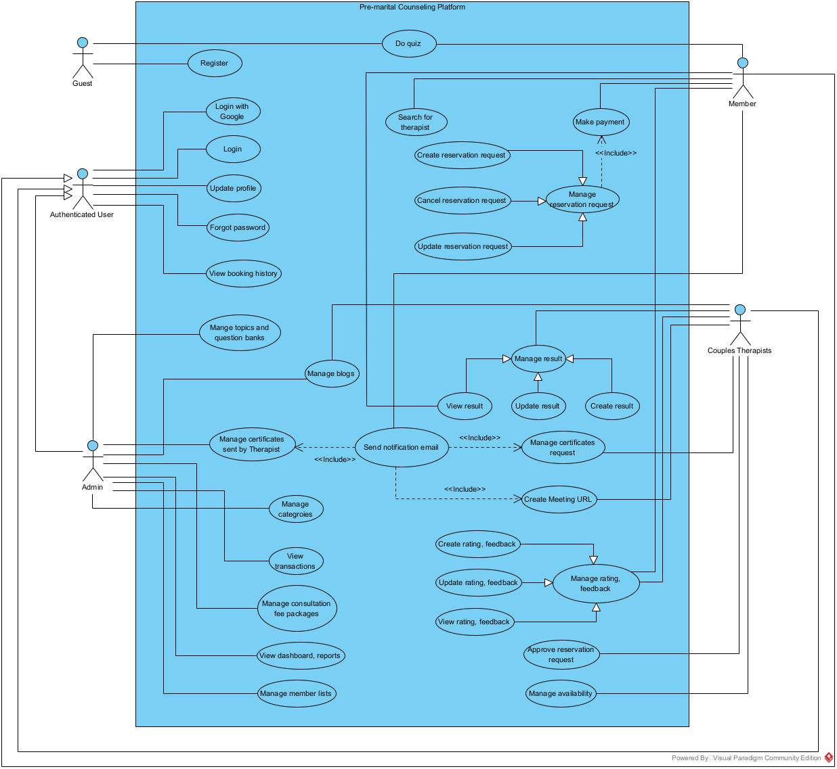

ID | Name | Actors | Description
UC-01 | Do Quiz | Guest, Member | This use case describes the process when a member takes a quiz. The user chooses an available quiz, answers the questions and submits their response. The system records the answers and evaluates the score
UC-02 | Register | Guest | This use case describes the process when a new user creates an account in the system. Upon successful registration, the user’s information will be stored
UC-03 | Login | Member, Admin, Couples Therapist | This use case describes the process when a registered user to access their account by providing valid credentials Upon successful authentication, the user gains access to the system's features based on their role or permissions
UC-04 | Update Profile | Member, Admin, Couples Therapist | This use case describes the process when a registered user modifies their profile information. The system validates the updated information before saving changes
UC-05 | Forgot Password | Member, Admin, Couples Therapist | This use case describes the process when the user wants to change a new password that they forget. The system will receive the email and check if that email is available and send the reset password link to the user
UC-06 | Change Password | Member, Admin, Couples Therapist | This use case describes the process when the user wants to change a new password. The system will check if the password in the database is correct
UC-07 | Manage Certificate Requests | Admin | This use case describes the process where an admin manages certificate requests submitted by couple therapists. The admin reviews, approves, or rejects requests, and the system updates the status accordingly
UC-08 | Manage Consultation Fee Packages | Admin | This use case describes how an admin manages consultation fee packages and commissions that experts must pay to the platform. The admin can create, update, and remove fee packages, set commission rates
UC-09 | View Dashboard and Reports | Admin | This use case describes how an Admin can view tables of business statistics
UC-10 | Manage Members List | Admin | This use case describes how an admin manages the list of registered members, including viewing, updating, deactivating, or removing members from the platform.
UC-11 | View Reservation History | Member, Couples Therapist, Admin | This use case describes how members, couple therapists and admin can view reservation history
UC-12 | Search for Therapist | Member | This use case allows a logged-in member to search for a therapist specializing in pre-marital counseling. The system retrieves relevant therapists based on the search query and displays their information.
UC-13 | Manage Ratings and Feedbacks | Member, Couples Therapist | This use case describes how members and couple therapists can manage ratings and feedback. Members can submit ratings and feedback for therapists, and therapists can view, respond to, or report feedback.
UC-14 | Send Certificate Requests | Couples Therapist | This use case describe how couples therapist manage their requests for certificates approval from admin
UC-15 | Manage Reservation Result | Couples Therapist | This use case describe how couple therapists manage the result of the reservation
UC-16 | Manage Reservation | Member, Couples Therapist | The use case describe how members can manage their consultation reservations
UC-17 | Make Payment | Member | The use case describe how members make payment for consultation
UC-18 | Create Meeting URL | Couples Therapist | Couples therapist create a meeting URL for consulting
UC-19 | Login With Google | Member, Couples Therapist | Member login with different method using Google account
UC-20 | Approve Reservation Request | Couples Therapist | The use case describe how couple therapist approve reservation request from members
UC-21 | Manage Availability | Couples Therapist | The use case describe how couple therapists manage their availability
UC-22 | Mange topics and question banks | Admin | The use case describe how admin manage all the topic and quizzes in the system
UC-23 | Manage blogs | Couple Therapist, Admin | The use case describe how couple therapists and admin manage their blogs
UC-24 | View transactions | Admin | The use case describe how admin can view all the transactions that occur in the system
UC-25 | Manage categories | Admin | The use case describe how admin can create, update, view, delete all the categories in the system

(Vũ)
Use Case Specification
Use Case ID and Name: | UC-01  Do Quiz
Created By: | Pham Nguyen Vu | Date Created: | 12/02/2025
Primary Actor: | Guest, Member | Secondary Actors: | System
Trigger: | The user selects a quiz to do
Description: | This use case describes the process when a member takes a quiz. The user chooses an available quiz, answers the questions and submits their response. The system records the answers and evaluates the score
Preconditions: | - The quiz is available to take
Post–conditions: | - The system records the answers and provides results
Normal Flow: | - User selects a quiz  - System displays questions  - User answers questions and submit  - System records the answers and returns the result
Alternative Flows:
Exceptions:
Priority: | High
Frequency of Use:
Business Rules:
Other Information:
Assumptions:

(Vũ)
Use Case Specification
Use Case ID and Name: | UC-02  Register
Created By: | Pham Nguyen Vu | Date Created: | 12/02/2025
Primary Actor: | Guest | Secondary Actors: | System
Trigger: | The user initiates registration by selecting "Sign Up”
Description: | The Register use case allows a new user to create an account in the system. Upon successful registration, the user’s information will be stored
Preconditions: | - User is not already registered
Post–conditions: | - A new user account is created in the system
Normal Flow: | - User accesses the register page  - User enters registration details and submit  - System validates inputs and store user’s information  - System sends verification email to the user
Alternative Flows:
Exceptions:
Priority: | High
Frequency of Use:
Business Rules: | BR-02, BR-03, BR-05, BR-06, BR-22
Other Information:
Assumptions:

(Vũ)
Use Case Specification
Use Case ID and Name: | UC-03  Login
Created By: | Pham Nguyen Vu | Date Created: | 13/02/2025
Primary Actor: | Member,Admin Couples Therapist | Secondary Actors: | System
Trigger: | - The user selects "Sign In" from the website.  - The user tries to access a restricted feature and is prompted to log in.
Description: | The Login use case allows a registered user to access their account by providing valid credentials Upon successful authentication, the user gains access to the system's features based on their role or permissions
Preconditions: | - The user is already registered in the system
Post–conditions: | - The user is authenticated and granted access to their account
Normal Flow: | - The user navigates to the Login page  - The user fills out the login form and submit  - If credentials are valid, the system grants access and redirects the user to their dashboard or homepage.
Alternative Flows:
Exceptions:
Priority: | High
Frequency of Use:
Business Rules: | BR-01
Other Information:
Assumptions:

(Vũ)
Use Case Specification
Use Case ID and Name: | UC-04  Update Profile
Created By: | Pham Nguyen Vu | Date Created: | 13/02/2025
Primary Actor: | Member, Admin, Couples Therapist | Secondary Actors: | System
Trigger: | The user selects "Edit Profile" from their account settings
Description: | The Update Profile use case allows a registered user to modify their profile information. The system validates the updated information before saving changes
Preconditions: | - The user must be logged into their account
Post–conditions: | - The user’s profile information is updated successfully in the system
Normal Flow: | - The user navigates to the profile settings page.  - The user modifies one or more fields  - The user submits the updated information.  - The system validates the changes  - If validation succeeds, the system updates the user’s profile in the database
Alternative Flows:
Exceptions:
Priority: | Medium
Frequency of Use:
Business Rules: | BR-04, BR-20, BR-22
Other Information:
Assumptions:

(Nhật Long)
Use Case Specification
Use Case ID and Name: | UC-05  Forgot Password
Created By: | Chu Phan Nhat Long | Date Created: | 13/02/2025
Primary Actor: | Member, Couple Therapist, Admin | Secondary Actors: | System
Trigger: | The user forgets their password and wants to retrieve the password
Description: | This use case describes the process when the user wants to change a new password that they forget. The system will receive the email and check if that email is available and send the reset password link to the user
Preconditions: | - The user must have an existing account  - The user must provide a valid email to receive the reset link.
Post–conditions: | - A password reset link or OTP is sent to the user's registered email or phone.  - The user can proceed to reset their password by clicking the link.  - If the user completes the reset process successfully, the new password is stored securely.
Normal Flow: | - The user clicks "Forgot Password".  - The user enters their email/phone and submits.  - The system verifies if the account exists and is valid.  - The system sends a reset link or OTP.  - The user enters a new password and submits it to the server.
Alternative Flows:
Exceptions:
Priority: | Medium
Frequency of Use:
Business Rules: | BR-05, BR-06
Other Information:
Assumptions:
(Nhật Long)
Use Case Specification
Use Case ID and Name: | UC-06  Change password
Created By: | Chu Phan Nhat Long | Date Created: | 13/02/2025
Primary Actor: | Member, Couple Therapist, Admin | Secondary Actors: | System
Trigger: | The user wants to change their password
Description: | This use case describes the process when the user wants to change a new password. The system will check if the password in the database is correct
Preconditions: | - The user has a registered account in the system.  - The old password must be correct
Post–conditions: | - The user's password is updated in the system.  - The user can log in using the new password.
Normal Flow: | - The user clicks on "Change Password" on the profile page.  - The user enters their old password, and new password and confirms the password.  - The system validates and updates the password.  - The system notifies the user that the password has been successfully changed.
Alternative Flows:
Exceptions:
Priority: | Medium
Frequency of Use:
Business Rules: | BR-05, BR-06
Other Information:
Assumptions:
(Nhật Long)
Use Case Specification
Use Case ID and Name: | UC-07  Manage certificate requests
Created By: | Chu Phan Nhat Long | Date Created: | 13/02/2025
Primary Actor: | Admin | Secondary Actors: | System, Couple Therapist
Trigger: | The couple therapist submits their certificates requests
Description: | This use case describes the process where an admin manages certificate requests submitted by couple therapists. The admin reviews, approves, or rejects requests, and the system updates the status accordingly.
Preconditions: | - The admin must be logged in with the appropriate permissions.  - Couples Therapist must have submitted certificate requests.
Post–conditions: | - The system updates and stores the request status.  - Couple Therapists are informed of the decision.  - Approved requests result.
Normal Flow: | - The admin logs into the system and navigates to the Certificate Requests section.  - The admin views a list of pending certificate requests.  - The admin selects a request to review and checks the provided details.  - The admin approves or rejects the request:  - If approved, the system saves the certificate.  - If rejected, the system stores the rejection reason.  - The system notifies the user about the decision.
Alternative Flows:
Exceptions:
Priority: | High
Frequency of Use:
Business Rules: | BR-08
Other Information:
Assumptions:

(Nhật Long)
Use Case Specification
Use Case ID and Name: | UC-08  Manage Consultation Fee Packages
Created By: | Chu Phan Nhat Long | Date Created: | 13/02/2025
Primary Actor: | Admin | Secondary Actors: | System, Couple Therapist
Trigger: | The admin initiates package management.
Description: | This use case describes how an admin manages consultation fee packages and commissions that experts must pay to the platform. The admin can create, update, and remove fee packages, set commission rates.
Preconditions: | - The admin must be logged in with the necessary permissions.
Post–conditions: | - Consultation fee packages and commission rates are stored and updated in the system.  - Experts are charged the correct commission for each consultation.  - The system tracks and records payments for financial reporting.
Normal Flow: | - The admin logs into the system and navigates to the Consultation Fees & Commissions section.  - The admin views existing fee packages and commission rates.  - The admin creates or updates a fee package.
Alternative Flows:
Exceptions:
Priority: | High
Frequency of Use:
Business Rules: | BR-12
Other Information:
Assumptions:

(Bảo)
Use Case Specification
Use Case ID and Name: | UC-09  View Dashboard And Reports
Created By: | Le Nguyen Chi Bao | Date Created: | 14/02/2025
Primary Actor: | Admin | Secondary Actors:
Trigger: | - The administrator logged in as Admin role account
Description: | - This use case describes how an Admin can view tables of business statistics
Preconditions: | - The admin must be logged in with the necessary permissions.
Post–conditions:
Normal Flow: | The admin logs into the system and automatically be navigated to Dashboard page
Alternative Flows:
Exceptions:
Priority: | Medium
Frequency of Use:
Business Rules: | BR-01
Other Information:
Assumptions:
(Bảo)
Use Case Specification
Use Case ID and Name: | UC-10  Manage Member List
Created By: | Trinh Han Hoang Long | Date Created: | 14/02/2025
Primary Actor: | Admin | Secondary Actors: | System
Trigger: | - The administrator logged in as Admin role account  - The admin accesses the member management section to view, update, or remove member information.
Description: | - This use case describes how an admin manages the list of registered members, including viewing, updating, deactivating, or removing members from the platform.
Preconditions: | - The admin must be logged into the system with appropriate permissions.  - The system must have a database of registered members.
Post–conditions: | Member information is updated, deactivated, or removed based on the admin's actions.
Normal Flow: | - The admin logs into the system.  - The admin navigates to the "Manage Member Lists" section.  - The system displays the list of registered members.  - The admin can perform the following actions:  - View member details.  - Update member information (e.g., contact details, membership status).  - Deactivate a member account.  - Remove a member from the system.  - The system saves the changes and updates the member list accordingly.
Alternative Flows: | A1: Member search/filter  - The admin can filter or search for specific members based on criteria such as name, email
Exceptions: | E1: Deleting a member with active reservations – If the admin tries to delete a member who has active reservations, the system prevents the action and notifies the admin.
Priority: | High
Frequency of Use: | Regularly
Business Rules: | BR-01, BR-02
Other Information:
Assumptions:
(Bảo)
Use Case Specification
Use Case ID and Name: | UC-11  View Reservation History
Created By: | Le Nguyen Chi Bao | Date Created: | 14/02/2025
Primary Actor: | Admin | Secondary Actors: | Couple Therapists, Members
Trigger: | - When user press on “Reservation History” button
Description: | - This use case describes how members, couple therapists and admin can view reservation history
Preconditions: | - Users must be logged in
Post–conditions:
Normal Flow: | - Admin logs into the system and is navigated to the Dashboard page.  - Admin selects "Reservation History."  - System retrieves and displays the reservation history.
Alternative Flows: | - Members and Couple Therapists click on their account icon for a dropdown menu.  - Members and Couple Therapists press on “Reservation History”
Exceptions: | No reservation history found  - System displays a message: "No reservation history available."
Priority: | - High
Frequency of Use: | - High
Business Rules: | BR-01
Other Information:
Assumptions:

(Hoàng Long)
Use Case Specification
Use Case ID and Name: | UC-12  Search for therapist
Created By: | Trinh Han Hoang Long | Date Created: | 14/02/2025
Primary Actor: | Member | Secondary Actors: | System
Trigger: | The user enters the therapist’s name in the search field.
Description: | This use case allows a logged-in member to search for a therapist specializing in pre-marital counseling. The system retrieves relevant therapists based on the search query and displays their information.
Preconditions: | - The user must be logged in with appropriate permissions.  - The system must have a pre-existing database of therapists.
Post–conditions: | - The system displays a list of therapists that match the user’s search criteria.
Normal Flow: | - The user logs into the platform.  - The user navigates to the search function.  - The user enters the name of the therapist in the search field.  - The system searches for therapists matching the entered name.  - The system displays the search results, showing relevant therapist details.  - The user views the therapist profiles and selects a desired therapist.
Alternative Flows: | A1: No matching therapist found  - If no therapist matches the search query, the system displays a message stating that no results were found.
Exceptions:
Priority: | Medium
Frequency of Use:
Business Rules: | BR-09, BR-10
Other Information:
Assumptions: | The therapist database is regularly updated and maintained.

(Hoàng Long)
Use Case Specification
Use Case ID and Name: | UC-13  Manage Rating And Feedback
Created By: | Trinh Han Hoang Long | Date Created: | 14/02/2025
Primary Actor: | Member, Couple Therapist, | Secondary Actors: | System
Trigger:
Description: | - This use case describes how members and couple therapists can manage ratings and feedback. Members can submit ratings and feedback for therapists, and therapists can view, respond to, or report feedback.
Preconditions: | - The user must be logged in with the appropriate permissions.  - The system must have a list of therapists and existing feedback  - The user must complete a reservation before being able to submit a rating and feedback.
Post–conditions: | - The system stores new or updated ratings and feedback.  - Feedback is visible to authorized users.
Normal Flow: | - The user logs into the platform.  - The user navigates to the your reservation  - The user click to view result which status is completed  - The user performs one of the following actions:  - Members:  - Submit a rating and feedback for a therapist.  - The system processes and updates the feedback accordingly.
Alternative Flows:
Exceptions:
Priority: | Medium
Frequency of Use:
Business Rules: | BR-19
Other Information:
Assumptions:
(Bảo)
Use Case Specification
Use Case ID and Name: | UC-14  Send Certificates Request
Created By: | Le Nguyen Chi Bao | Date Created: | 14/02/2025
Primary Actor: | Couples Therapist, Admin | Secondary Actors: | System
Trigger: | Couple Therapists press “Send Request” button
Description: | The use case describe how couples therapist manage their requests for certificates approval from admin
Preconditions: | Couple therapist must logged with their account
Post–conditions:
Normal Flow: | - Therapists click on their user icon to open the dropdown menu.  - Therapists select the “Profile” option.  - Therapists input their certificate URL.  - Therapists click the “Send Request” button.  - System confirms the request has been sent.
Alternative Flows: | Request submission fails  - System displays an error message indicating the reason.
Exceptions:
Priority: | High
Frequency of Use:
Business Rules: | BR-01, BR-04, BR-08
Other Information:
Assumptions:
(Bảo)
Use Case Specification
Use Case ID and Name: | UC-15  Manage Reservation Result
Created By: | Le Nguyen Chi Bao | Date Created: | 14/02/2025
Primary Actor: | Couples Therapist, | Secondary Actors: | Member
Trigger:
Description: | The use case describe how couple therapists manage the result of the reservation
Preconditions: | Couple therapists and members must logged in with their accounts
Post–conditions: | Couple therapists and members must attend the consultation
Normal Flow: | - Couple therapists press on “Create consultation result”  - Couple therapists fill all required fields  - Therapists press “Confirm” button from the pop up
Alternative Flows: | - User click on “Profile” icon  - Reservation result item  - Consultation detail display on the pop up
Exceptions:
Priority: | High
Frequency of Use: | High
Business Rules: | BR-01, BR-04, BR-08
Other Information:
Assumptions:

(Bảo)
Use Case Specification
Use Case ID and Name: | UC-16  Manage Reservation
Created By: | Le Nguyen Chi Bao | Date Created: | 14/02/2025
Primary Actor: | Member,  Couples Therapist | Secondary Actors:
Trigger: | Members press on “Create Reservation” button
Description: | The use case describe how members can manage their consultation reservations
Preconditions: | User must logged in with their account
Post–conditions:
Normal Flow: | - Members search for available couples therapists.  - Members choose a session based on availability.  - Members press the “Confirm” button.  - System confirms the reservation.
Alternative Flows: | No therapists available  - System displays a message: "No therapists available at this time."
Exceptions: | System error during reservation  - System displays an error message.
Priority: | High
Frequency of Use: | High
Business Rules: | BR-01, BR-04, BR-08
Other Information:
Assumptions:
(Bảo)
Use Case Specification
Use Case ID and Name: | UC-17  Make Payment
Created By: | Le Nguyen Chi Bao | Date Created: | 14/02/2025
Primary Actor: | Member,  Couple Therapist | Secondary Actors:
Trigger: | Members click on “Confirm” button
Description: | The use case describe how members make payment for consultation
Preconditions: | Members must logged in with their account
Post–conditions: | Members must filled in all required input of consultation reservation form and click “Confirm” button
Normal Flow: | - Members click on the “Make Payment” button.  - A payment popup appears.  - Members fill in the necessary payment details and click “Submit.”  - System processes the payment and confirms the transaction.
Alternative Flows: | Payment fails  - System displays an error message explaining the failure.
Exceptions: | Invalid payment information  - System prompts the user to correct the information.
Priority: | High
Frequency of Use: | High
Business Rules: | BR-01, BR-04, BR-08
Other Information:
Assumptions:

(Hoàng Long)
Use Case Specification
Use Case ID and Name: | UC-18  Create Meeting URL
Created By: | Trinh Han Hoang Long | Date Created: | 14/02/2025
Primary Actor: | Couple Therapist | Secondary Actors: | System
Trigger: | Members click on “Create meeting URL” button
Description: | Couple therapist create a meeting URL for consulting
Preconditions: | - Couple therapist must login with their accounts  - Member had created a reservation
Post–conditions:
Normal Flow: | - The couple therapist logs into the system.  - The couple therapist navigates to the "Reservations" section.  - The system retrieves reservations.  - The couple therapist click “Create Meeting URL” button
Alternative Flows:
Exceptions:
Priority: | High
Frequency of Use:
Business Rules: | BR-18
Other Information:
Assumptions: | The system correctly stores and retrieves assessment data.

(Hoàng Long)
Use Case Specification
Use Case ID and Name: | UC-19  Login with Google
Created By: | Trinh Han Hoang Long | Date Created: | 14/02/2025
Primary Actor: | Member,  Couple Therapist | Secondary Actors: | System
Trigger: | Members click on “Login with Google” button
Description: | Member login with different method using Google account
Preconditions: | - The user must have a google account
Post–conditions: | - The user is authenticated and granted access to their account
Normal Flow: | - Guest navigate to “Login page”  - Guest clicked on “Login with Google” button
Alternative Flows:
Exceptions:
Priority: | Medium
Frequency of Use:
Business Rules: | BR-02, BR-03
Other Information:
Assumptions: | The system correctly stores and retrieves account
(Hoàng Long)
Use Case Specification
Use Case ID and Name: | UC-20  Approve Reservation Request
Created By: | Trinh Han Hoang Long | Date Created: | 14/02/2025
Primary Actor: | Couple Therapist | Secondary Actors:
Trigger: | Members click on “Approve” button or “Deny” button
Description: | The use case describe how couple therapist approve reservation request from members
Preconditions: | - Member must created a reservation request
Post–conditions:
Normal Flow: | - The couple therapist logs into the system.  - The couple therapist navigates to the "Reservations" section.  - The system retrieves reservations.  - The couple therapist click “Approve” button or “Deny” button
Alternative Flows:
Exceptions:
Priority: | Medium
Frequency of Use:
Business Rules: | BR-14
Other Information:
Assumptions:
(Bảo)
Use Case Specification
Use Case ID and Name: | UC-21  Manage availability
Created By: | Le Nguyen Chi Bao | Date Created: | 14/02/2025
Primary Actor: | Couple Therapist | Secondary Actors:
Trigger: | Members click on “Approve” button or “Deny” button
Description: | The use case describe how couple therapists manage their availability
Preconditions: | - Couple Therapist must login with their account
Post–conditions:
Normal Flow: | - The couple therapist logs into the system.  - The couple therapist navigates to the "Availability" page.  - The system display a schedule of availability  - The couple therapist click on the blank slot to create new availability  - The couple therapist click on the slot with content to update availability
Alternative Flows:
Exceptions:
Priority: | Medium
Frequency of Use:
Business Rules: | BR-14
Other Information:
Assumptions:
(Vũ)
Use Case Specification
Use Case ID and Name: | UC-22  Manage Blogs
Created By: | Pham Nguyen Vu | Date Created: | 14/02/2025
Primary Actor: | Couple Therapist, Admin | Secondary Actors:
Trigger: | - User selects "Create New Blog" – When an Admin or Therapist wants to write and publish a new blog.  - User selects an existing blog to edit – When an Admin or Therapist wants to update or modify a published or draft blog.  - User selects "Delete" on a blog post – When an Admin or Therapist wants to remove a blog post.
Description: | - This use case describes how Admins and Couple Therapists manage blog posts within the system. The blog section allows professionals to share insights, research, and advice.
Preconditions: | - The user (Admin or Therapist) must be logged into the system.  - The Therapist must have an approved account to submit blogs.
Post–conditions: | - If successful, the blog is published or saved as a draft.  - If deleted, the blog is removed from the system.
Normal Flow: | - The user navigates to the "Manage Blog" section.  - The user selects "Create New Blog."  - The system presents a blog editor where the user enters:  - Title  - Content  - Images/Videos (optional)  - Category  - The user clicks ”Publish”
Alternative Flows: | - The user selects an existing blog.  - The system opens the editor with the current content.  - The user makes changes and submits.  - The blog is updated upon approval.
Exceptions: | - If the user tries to publish without required fields, an error message appears.  - If the system fails to save, an error message is displayed.
Priority: | Medium
Frequency of Use:
Business Rules: | BR-23
Other Information:
Assumptions:
(Nhật Long)
Use Case Specification
Use Case ID and Name: | UC-23  Manage topics and question banks
Created By: | Chu Phan Nhat Long | Date Created: | 14/02/2025
Primary Actor: | Admin | Secondary Actors:
Trigger: | - The Admin initiates an action by accessing the system to create, edit, or delete a topic or question bank.
Description: | - This use case describes how the Admin manages topics and question banks within the system. Topics are used to categorize content, while question banks store sets of questions related to specific topics.
Preconditions: | - The Admin must be logged into the system.  - The Admin must have appropriate permissions to manage topics and question banks.
Post–conditions: | - If successful, topics and question banks are created, updated, or deleted.  - If deleted, the content is removed or archived.
Normal Flow: | - Manage Topics  - The Admin navigates to the "Manage Topics" section.  - The Admin selects "Create New Topic."  - The system presents a form where the Admin enters:  - Topic Title  - Topic Description  - The Admin clicks "Save" or "Publish" to make it available.  - The system saves the topic and makes it accessible for related content.  - Manage Question banks  - The Admin navigates to "Manage Question Bank."  - The Admin selects "Create New Question Bank."  - The system presents a form where the Admin enters:  - Question Bank Title  - Associated Topics  - The Admin clicks "Save" or "Publish."  - The system saves the question bank and associates it with the selected topics.
Alternative Flows: | - Admin Attempts to Create a Topic Without Required Fields  - The Admin selects "Create New Topic."  - The Admin leaves the Topic Title or Description empty.  - The system displays an error message: "Topic Title and Description are required."  - The Admin must enter the missing details before proceeding.  - Admin Attempts to Create a Duplicate Topic  - The Admin enters a Topic Title that already exists in the system.  - The system notifies the Admin: "A topic with this title already exists. Please choose a different title."  - The Admin must modify the title before saving.  - Admin Attempts to Delete a Topic that is in Use  - The Admin selects a topic and clicks "Delete."  - The system checks if the topic is linked to existing question banks.  - If linked, the system displays a message: "This topic is associated with active question banks. Remove the associations before deleting."  - The Admin must unlink the topic from question banks before proceeding with deletion.  - Admin Attempts to Create a Question Bank Without Selecting a Topic  - The Admin selects "Create New Question Bank."  - The Admin does not select an Associated Topic and tries to save.  - The system displays an error message: "At least one associated topic is required for a question bank."  - The Admin must select a topic before saving.  - Admin Attempts to Delete a Question Bank that Contains Questions  - The Admin selects a question bank and clicks "Delete."  - The system checks if the question bank contains questions.  - If it contains questions, the system displays: "This question bank contains questions. Delete or move the questions before removing the question bank."  - The Admin must remove or relocate the questions before proceeding with deletion.
Exceptions: | - If required fields are missing, the system prompts the Admin to complete them.  - If the system encounters an error while saving, an error message is displayed.
Priority: | High
Frequency of Use:
Business Rules: | BR-24, BR-25
Other Information:
Assumptions:

Use Case Specification
Use Case ID and Name: | UC-24  View Transactions
Created By: | Pham Nguyen Vu | Date Created: | 24/03//2025
Primary Actor: | Admin | Secondary Actors: | System
Trigger: | The user goes to “Transaction History” page
Description: | This use case describes the process when a user views transaction records. The admin accesses the transaction history, reviews details of past transactions.
Preconditions: | -The user has logged in and has the necessary permissions to access transaction records.  - Transaction data exists in the system.
Post–conditions: | - The system displays the transaction records to the user.  - The user can view transaction details, including amounts and dates.
Normal Flow: | - User selects the "View Transactions" option.  - System retrieves and displays transaction records.  - User views transaction details.
Alternative Flows: | - Transaction records not found: If no transactions exist, the system displays an appropriate message.
Exceptions:
Priority: | High
Frequency of Use: | Regularly used by admins for monitoring and reporting
Business Rules: | BR-26
Other Information:
Assumptions:

Use Case Specification
Use Case ID and Name: | UC-25  Manage Categories
Created By: | Chu Phan Nhat Long | Date Created: | 24/03/2025
Primary Actor: | Admin | Secondary Actors:
Trigger: | The admin access to the categories view section in dashboard
Description: | The use case describe how admin can create, update, view, delete all the categories in the system
Preconditions: | - The admin is authenticated and authorized.  - The system is accessible and operational
Post–conditions: | - The category data is updated (created, edited, or deleted) and reflected throughout the system.
Normal Flow: | - Admin navigates to the "Manage Categories" interface.  - System displays a list of existing categories.  - Admin selects an action:  - Add New Category  - Edit Existing Category  - Delete Category  - For Add/Edit, Admin enters or updates:  - Category name  - Description (optional)  - Admin confirms the action.  - System validates and saves the changes.  - System displays success confirmation.
Alternative Flows: | 3a. Invalid Data:  - System detects missing or invalid inputs (e.g., empty name).  - System shows an error message and prompts correction.  3b. Delete Confirmation:  - System prompts confirmation before deletion.  - If category is associated with items, system prevents deletion or reassigns items.  5a. Network/System Failure:  - System displays an error message and logs the event.
Exceptions:
Priority: | Medium
Frequency of Use: | Occasional – typically used during content/product setup or updates.
Business Rules: | BR-27
Other Information:
Assumptions:

3. Functional Requirements

3.1 System Functional Overview

The system connects members with premarital counseling experts, providing functionalities such as booking counseling sessions, managing therapists, handling payments, and collecting feedback.

3.1.1 System User Roles

The system includes four main user roles:

Admin

Manage members.

Approve or decline therapist profiles.

Manage system policies.

View Dashboard and system analytics.

Couples Therapist

Provide counseling sessions.

Manage availability schedules.

Review and update client profiles.

Submit counseling session reports.

Update professional information, service fees.

Member

Book counseling sessions.

Access educational materials and resources.

Communicate with therapists.

Rate and review counseling services.

Guest

Browse platform information, blog, and public resources.

Take premarital quizzes.

Register for an account.

3.2 Profile Management (Hoàng Long)

3.2.1 View Profile

Description: Users can view their own profile or a therapist’s profile.

Actors: Member, Couples Therapist, Admin.

Preconditions:

The user must be logged in.

The user must have permission to view the profile.

Flow:

The user navigates to the profile page.

The system displays personal details, professional background, availability, and ratings for therapists.

3.2.2 Edit Profile

Description: Users can edit their personal information.

Actors: Member, Couples Therapist, Admin.

Preconditions: The user must be logged in and have permission to edit their profile.

Flow:

The user selects "Edit Profile."

The system presents an editable form.

The user updates information and saves the changes.

3.3 Appointment Booking (Hoàng Long)

3.3.1 Search for a Therapist

Description: Members can search for therapists based on specific criteria.

Actors: Member

Flow:

The member enters search criteria (expertise, name).

The system filters and displays a list of matching therapists.

The member selects a therapist to view their profile.

3.3.2 Book an Appointment

Description: Members can schedule a counseling session with a therapist.

Actors: Member, Couples Therapist.

Preconditions: The member must have selected a therapist and logged in.

Flow:

The member selects an available time slot.
  - The member pay 50% the price

The system sends a booking request.

The therapist confirms the appointment.

The system notifies the member about the confirmation.

3.3.3 Conduct Counseling Session

Description: Members attend counseling sessions via an online platform.

Actors: Member, Couples Therapist.

Preconditions: The appointment must be confirmed.

Flow:

Both parties join the session via an integrated video call (Google Meet).

The therapist records session notes.

The member provides a rating and review after the session.

3.4 Payment Management (Hoàng Long)

3.4.1 Payment Processing

Description: Members complete payments for counseling services.

Actors: Member, Admin.

Preconditions: The member has scheduled an appointment.

Flow:

The member selects a payment method.

The system processes the transaction.

The system confirms the payment.

3.4.2 Refund & Cancellation Policy

Description: Members can cancel appointments and request a refund.

Actors: Member, Admin.

Preconditions: The appointment must not have started.

Flow:

The member requests cancellation.

The system checks the refund policy.

The system processes the refund if applicable.

3.5 Review & Feedback (Hoàng Long)

3.5.1 Rate a Therapist

Description: Members can rate and review therapists after sessions.

Actors: Member

Preconditions: The session must be completed.

Flow:

The member submits a rating and feedback.

The system stores and displays the review.

3.5.2 View Ratings & Feedback

Description: Therapists can view client feedback.

Actors: Couples Therapist

Preconditions: The therapist must have received reviews.

Flow:

The therapist accesses the feedback section.

The system displays ratings and comments from past clients.

3.6 Dashboard & Reporting (Hoàng Long)

3.6.1 Admin Dashboard

Description: Admins can view system statistics and manage

Actors: Admin.

Flow:

The admin accesses the Dashboard.

The system displays analytics, including session count, and revenue.
  - Manage users, questions, topics, options, and question banks.

4. Non-Functional Requirements (Vũ, Nhật Long, Bảo, Hoàng Long)

4.1 External Interfaces
This section defines the external interfaces required to ensure smooth communication between the system, users, and external hardware or software elements.

4.1.1 User Interfaces
The Pre-marital Counseling Platform will provide an intuitive and interactive interface to enhance the user experience.
- Web-Based Interface:
  - Responsive web design to support desktop, tablet, and mobile devices.
  - User-friendly navigation with clear menu options for booking sessions, accessing resources, and interacting with counselors.
  - Secure user authentication (sign-up, login, password recovery).
  - Dashboard for users to track progress, upcoming sessions, and received advice.
  - Integration with third-party video conferencing tools (Zoom, Google Meet) by providing session links.
  - Support for feedback submission and survey forms for continuous improvement.

4.1.2 Hardware Interfaces
The system will be designed to work with various hardware components, ensuring compatibility with multiple devices.
- End-User Devices:
  - Desktops and Laptops (Windows, macOS, Linux)
  - Smartphones and Tablets (iOS, Android)

4.1.3 Software Interfaces
The platform will interact with various third-party software solutions to provide seamless services.
- Operating System Compatibility:
  - Windows, macOS for desktop users.
  - Android and iOS for mobile users.
- Web Technologies:
  - Frontend: ReactJS
  - Backend: NodeJS, ExpressJS
  - Database: MongoDB
  - Authentication: Firebase Authentication / OAuth 2.0
- Third-Party Integrations:
  - Blog Management: Hygraph
  - Payment Gateway: VN Pay for secure transactions.
  - Video Conferencing: Instead of direct API integration Google Meet will be shared with users via email or dashboard.

4.1.4 Communication Interfaces
The platform will support various communication channels to facilitate interactions between users and counselors.
- Messaging Protocols:
  - Real-time chat functionality using WebSockets (Socket.io) or Firebase Realtime Database.
  - Email notifications for appointment reminders, session summaries, and updates.
- API Integration:
  - RESTful API endpoints for fetching counseling materials, scheduling sessions, and processing payments.
  - Secure API communication using HTTPS and JWT authentication.

4.2 Quality Attributes
The Pre-Marital system must meet the following quality attributes to ensure reliability, usability, security, and performance:

1. Performance
- The system should provide a response time of less than 2 seconds for 95% of requests.
- The system should support at least 500 concurrent users without performance degradation.

2. Security
- All sensitive user data, including passwords, must be encrypted using industry-standard encryption algorithms.
- The system must implement role-based access control (RBAC) to restrict unauthorized access to sensitive information.
- The system should enforce secure password policies, requiring a minimum of 8 characters, including uppercase, lowercase, numbers, and special characters.

3. Usability
- The UI should be responsive and compatible with all modern browsers and mobile devices.
- All error messages must be user-friendly and provide guidance on how to resolve the issue.
- The system should allow seamless navigation with intuitive design and easy-to-use forms.

4. Availability
- The system must have an uptime of 99.9% to ensure continuous service availability.

5. Maintainability & Scalability
- The system should be built with modular architecture to allow easy updates and enhancements.
- The backend should be scalable to accommodate increasing numbers of users and transactions.
- The codebase should follow best practices for readability and maintainability.

6. Data Integrity
- All user inputs must be validated to prevent data corruption and inconsistencies.
- Transactional operations must be ACID-compliant to ensure consistency in data processing.

5. Requirement Appendix (Hoàng Long)
This section lists additional requirements, constraints, and supporting information related to the Pre-Marital system.

1. Regulatory Compliance
- The system must comply with GDPR and local data protection laws for handling user information.
- Terms of Service and Privacy Policy must be presented and accepted by users before account creation.

2. Supported Platforms & Technologies
- Frontend: React.js
- Backend: Node.js with Express
- Database: MongoDB
- Hosting: Microsoft Azure

3. Third-Party Integrations
- Google OAuth for authentication.
- Google Meet integration for online consultations.
- VNPay for secure online payments.
- Email notifications for user interactions and system updates.
- Hygraph for publishing blogs.
- Imgur for storing images.

4. Constraints
- The system requires an active internet connection for online consultation and payment processing.
- The maximum file upload size should be 10MB.

5. Future Enhancements
- AI-based compatibility matching for partners.
- Advanced analytics for relationship trends and counseling recommendations.

5.1 Business Rules
No | Rule Definition
BR-01 | If the account is correct, system redirect users to corresponding home page:  - User logs in as role “admin”, the system will display admin Dashboard page  - User logs in as role “couple therapist”, the system will display homepage  - User logs in as role “member”, the system will display homepage
BR-02 | Email must be unique for user
BR-03 | Email must be in standard email format Ex: name@gmail.com
BR-04 | Account profile can be updated by only its owner
BR-05 | Password length must have at least 8 characters
BR-06 | Password must have 1 normal character, 1 capitalized character, 1 number character and 1 special character
BR-07 | Guest must create account before making reservation with a therapist
BR-08 | Couple Therapists must submit their qualifications for verification before approval.
BR-09 | Only approved experts can offer consultation services.
BR-10 | Members can search and filter couple therapists based on expertise, ratings, and availability.
BR-11 | Sessions are conducted via online meeting tools (e.g., Google Meet).
BR-12 | Couple Therapists must pay a commission on each session to the platform.
BR-13 | The system tracks and reports expert earnings and commissions
BR-14 | Couple Therapists must provide and maintain accurate profile information (name, expertise, qualifications).
BR-15 | Members must prepay 50% for consultation services.
BR-16 | If a member cancels before the consultation, they receive a refund (based on policy).
BR-17 | If an expert cancels, the system automatically processes a refund
BR-18 | Experts must log results after each session.
BR-19 | Members can rate and provide feedback after each consultation
BR-20 | Date must follow the dd/mm/yyyy format
BR-21 | Username must be unique
BR-22 | Length of full name must be between 5 to 50 characters
BR-23 | Only Admin and Couple Therapist can publish blog
BR-24 | Only Admin can create, edit, delete topics and question banks
BR-25 | A topic must be created before associating a question bank with it
BR-26 | Only Admin can access transaction records.
BR-27 | Only Admin can manage categories

5.2 Common Requirements
[Fill all the common requirements here..]

5.3 Application Messages List

Pages | Message Type | Context | Content
Login | Toast success | Email - Password correct | Login Successfully
 | Toast warning | Invalid Email - Password | Incorrect email or password
 | Input error | Email empty | Please enter your email
 |  | Email invalid | Please enter a valid email address
 |  | Password empty | Please enter your password
Register | Toast success | Email has not been used for register | Sign up successfully
 | Toast warning | Email has been already used for register | Email already in use
 | Input error | Full name field is left empty | Full name is required
 |  | Full name is invalid | Invalid name
 |  | Email field is left empty | Email is required
 |  | Email is invalid | Invalid email
 |  | Password field is left empty | Password is required
 |  | Password field is invalid | Password must contain at least one uppercase letter, one lowercase letter, one number, and one special character
 |  | Password’s length is less than 8 | Password must be at least 8 characters long
 |  | Confirm password field is left empty | Confirm password is required
 |  | Confirm password doesn’t match with password | Passwords do not match
Home | Toast info | User successfully logs into their account | Welcome user
Reservation | Toast success | User successfully books a session with an expert | Your reservation has been created successfully
 | Toast error | User attempts to create a reservation, but there’s an issue | Reservation failed. Please try again later
 | Toast success | User successfully changes the date/time of an existing reservation | Reservation rescheduled successfully
 | Toast error | User attempts to reschedule, but something goes wrong | Error updating your reservation
 | Toast success | User cancels an upcoming reservation | Reservation canceled successfully
 | Toast error | User tries to cancel, but the system prevents it | Unable to cancel your reservation. Please contact support
Payment | Toast success | User completes payment for a reservation | Payment successful! Your consultation is now confirmed.
 | Toast error | User attempts to pay, but the transaction fails | Payment failed! Please check your card details and try again
Therapist Profile | Toast success | Therapist updates their profile information | Your profile has been updated successfully
 | Toast error | Therapist encounters an error while saving updates | Failed to update profile. Please check your details
 | Toast success | Therapist modifies their availability | Schedule updated successfully
 | Toast error | Therapist tries to change their availability but fails | Error saving schedule changes
Rating & Feedback | Toast success | User successfully leaves a review | Thank you for your feedback! Your review has been submitted
 | Toast error | User attempts to submit feedback, but an issue occurs | Feedback submission failed! Please try again
 | Toast success | User edits their existing feedback | Your rating has been updated!
 | Toast error | User tries to modify a previous rating but encounters an error | Error updating your rating. Try again later
Admin Dashboard | Toast success | Admin modifies platform configurations | Settings updated successfully!
 | Toast error | Admin fails to modify a system setting | Error updating settings. Please try again
Blog | Toast success | User publishes a blog successfully | Blog created successfully
 | Toast error | User tries to publish a blog but fails | There is an error occurred when creating a blog

IV. Software Design Description

1. System Design

1.1 System Architecture (Vũ, Nhật Long, Bảo, Hoàng Long)
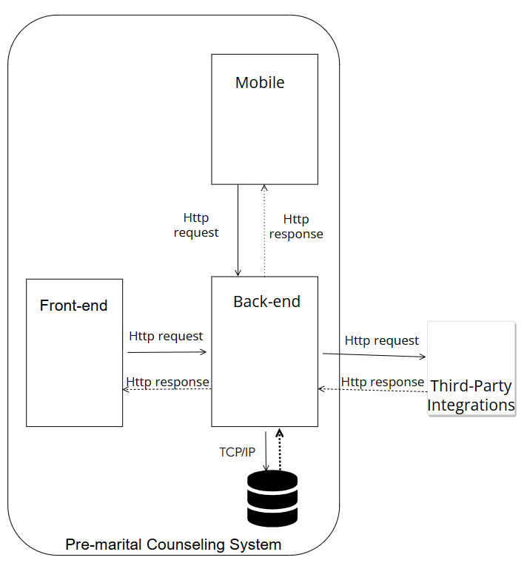

1.2 Package Diagram (Vũ, Nhật Long, Bảo, Hoàng Long)
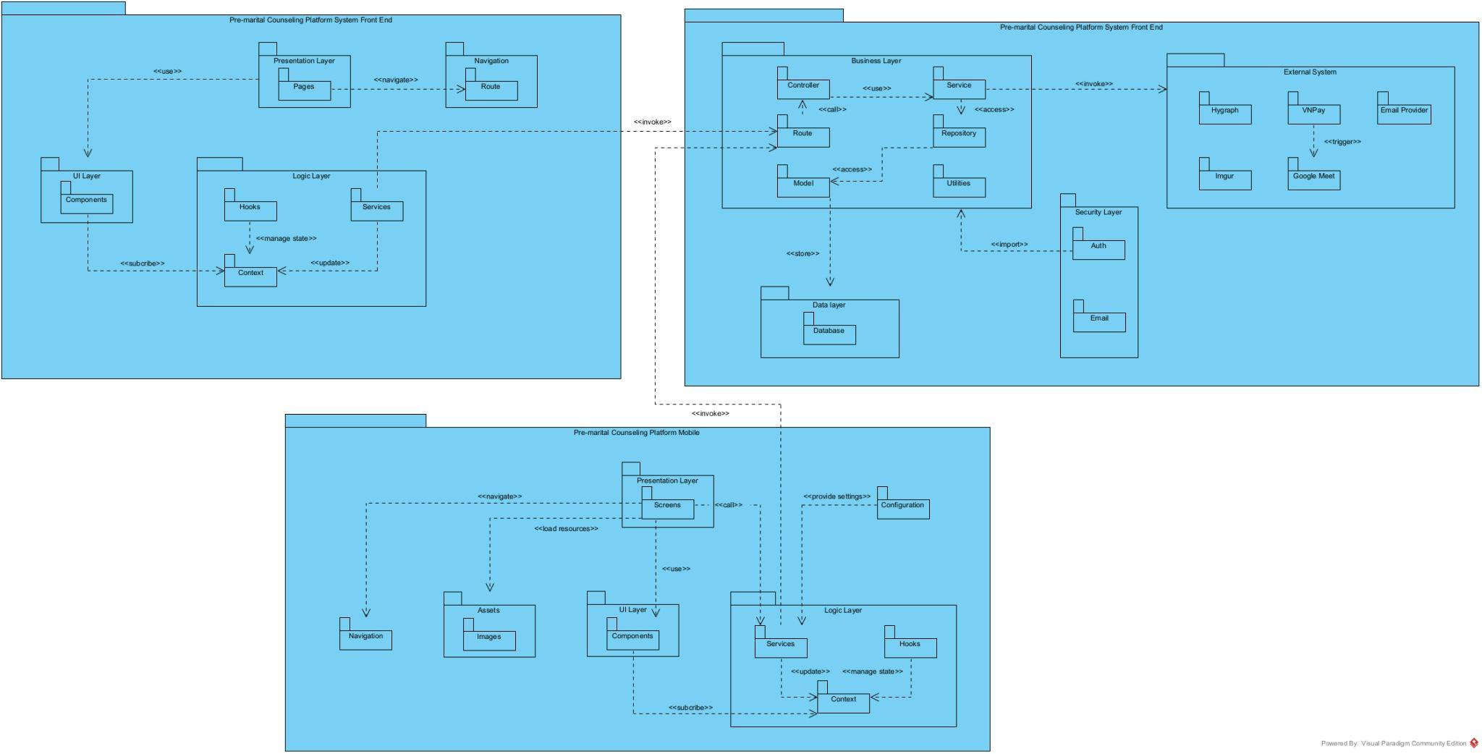

2. Database Design
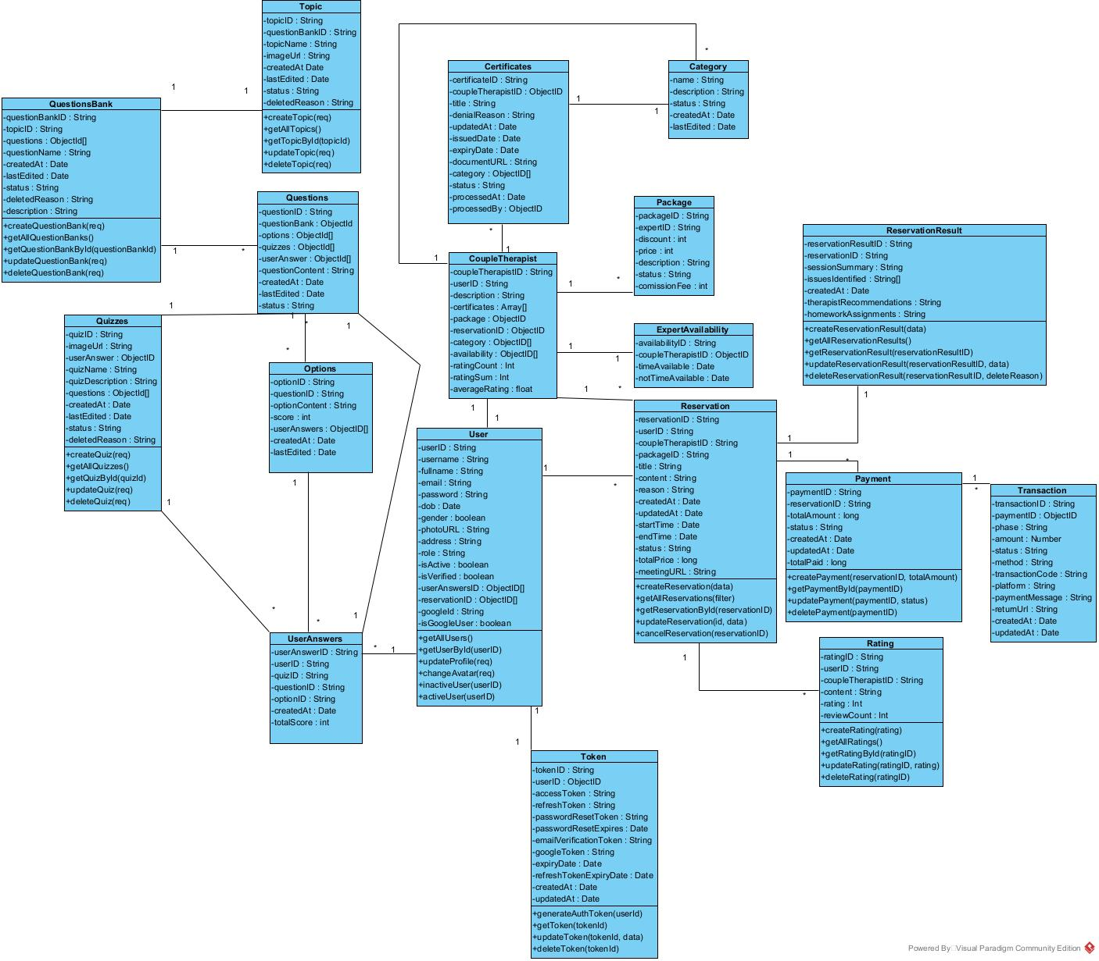

Collection Name | Attributes | Description
User | userID, username, fullname, email, password, dob, gender, photoURL, address, isVerified, isActive, googleID, userAnswerID, reservationID, googleId, isGoogleUser | Stores user information including personal details, login credentials, verification status, and social logins.
CoupleTherapist | coupleTherapistID, userID, description, certificates, package, reservationID, category, availability, ratingCount, ratingSum, averageRating | Details about couple therapists including their experience, expertise, availability, profile, and ratings.
Certificates | certificateID, coupleTherapistID, title, denialReason, updatedAt, issuedDate, expiryDate, documentURL, category, status, processedAt, processedBy | Certificates earned by therapists, including title, issuer, file, and audit trail.
Category | name, description, status, createdAt, lastEdited | Categories that classify therapist expertise or quiz content.
Package | packageID, expertID, discount, price, description, status, commissionFee | Service packages offered by therapists including discount, cost, and commission structure.
ExpertAvailability | availabilityID, coupleTherapistID, timeAvailable, notTimeAvailable | Schedules indicating therapist availability and unavailable time slots.
Reservation | reservationID, userID, coupleTherapistID, packageID, title, content, reason, createdAt, updatedAt, startTime, endTime, status, totalPrice, meetingURL | Booking details for therapy sessions including date, time, status, and cancellation info.
ReservationResult | reservationResultID, reservationID, sessionSummary, issuesIdentified, createdAt, therapistRecommendations, homeworkAssignments | Results and summaries of completed reservations including feedback and identified issues.
Payment | paymentID, reservationID, totalAmount, status, createdAt, updatedAt, totalPaid | Payment records for reservations, including payment method, amount, and status.
Transaction | transactionID, paymentID, phase, amount, status, method, transactionCode, platform, paymentMessage, returnURL, createdAt, updatedAt | Detailed transaction logs linked to payment and reservation for audit purposes.
Rating | ratingID, userID, coupleTherapistID, rating, content, reviewCount | Stores user-submitted ratings and comments for therapists.
Token | tokenID, userID, accessToken, refreshToken, passwordResetToken, passwordResetExpires, emailVerificationToken, googleToken, expiryDate, refreshTokenExpiryDate, createdAt, updatedAt | Authentication and authorization tokens with expiration and provider details.
Topic | topicID, questionBankID,questions, createdAt, lastEdited, status, deletedReason, description | Topic details including name, image, status, and related question banks.
QuestionsBank | questionBankID, topicID, questions, createdAt, lastEdited, description | A collection of questions grouped under a topic.
Questions | questionID, questionBank, options, quizzes, userAnswer, questionContent, createdAt, lastEdited, status | Individual questions with type, options, correct answer, and creation data.
Options | optionID, questionID, optionContent, score, userAnswers, createdAt, lastEdited | Options associated with multiple-choice questions and their corresponding scores.
UserAnswers | userAnswerID, userID, quizID, questionID, optionID, createdAt, totalScore | User-submitted answers linked to quizzes and questions, including scores.
Quizzes | quizID, imageURL, userAnswer, quizName, quizDescription, createdAt, lastEdited, status, deleteReason | Quiz metadata including name, description, linked answers, and status.

3. Detailed Design

3.1 Login (Vũ, Nhật Long)

3.1.1 Class Diagram
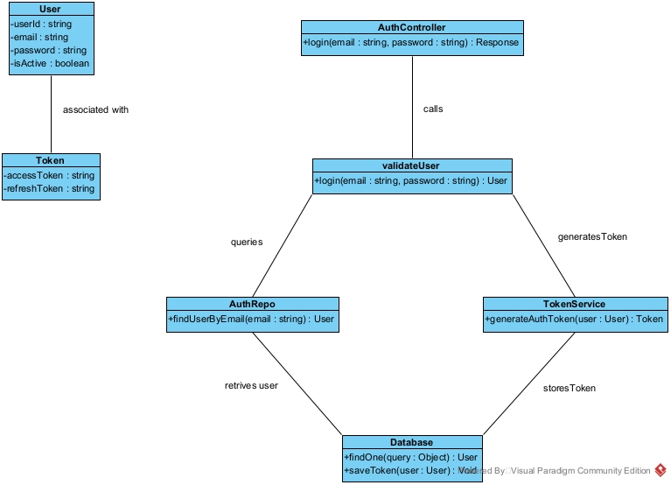
3.1.2 Sequence diagram
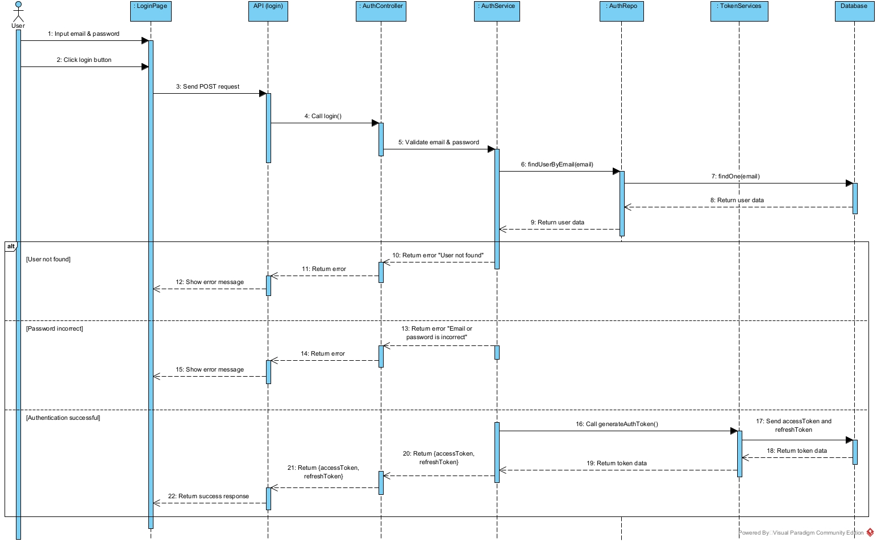

3.2 Register (Vũ, Nhật Long)
3.2.1 Class diagram
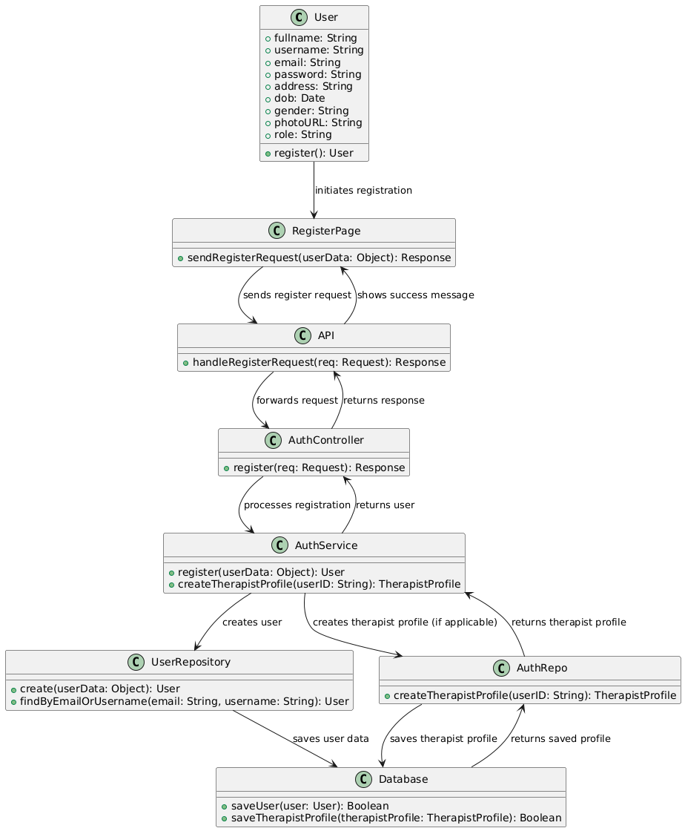
3.2.2 Sequence diagram

3.3 Forgot Password (Vũ, Nhật Long)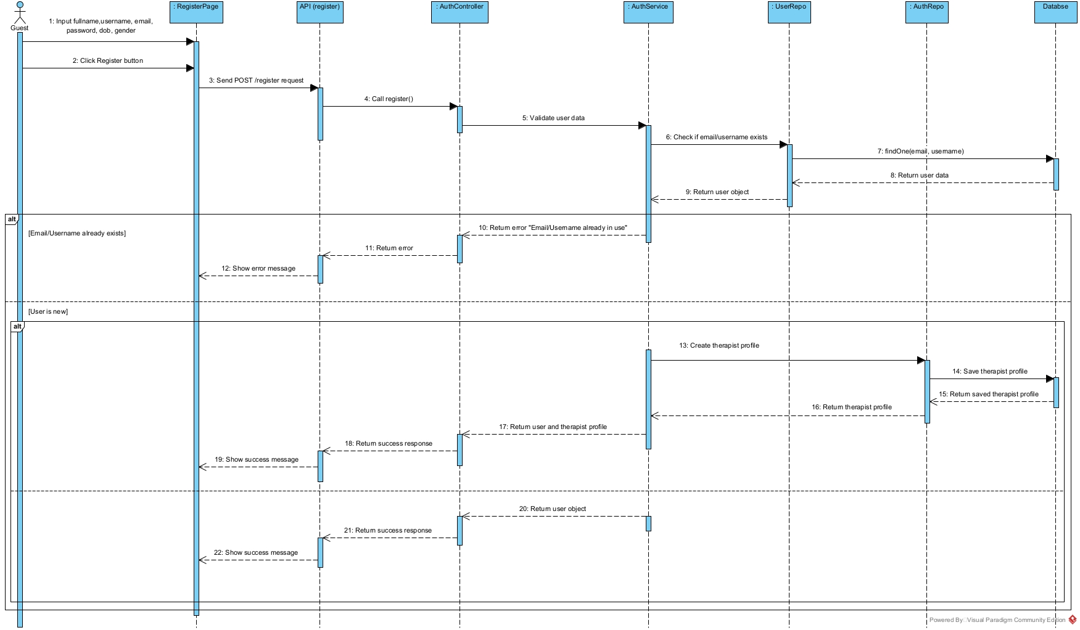
3.3.1 Class diagram
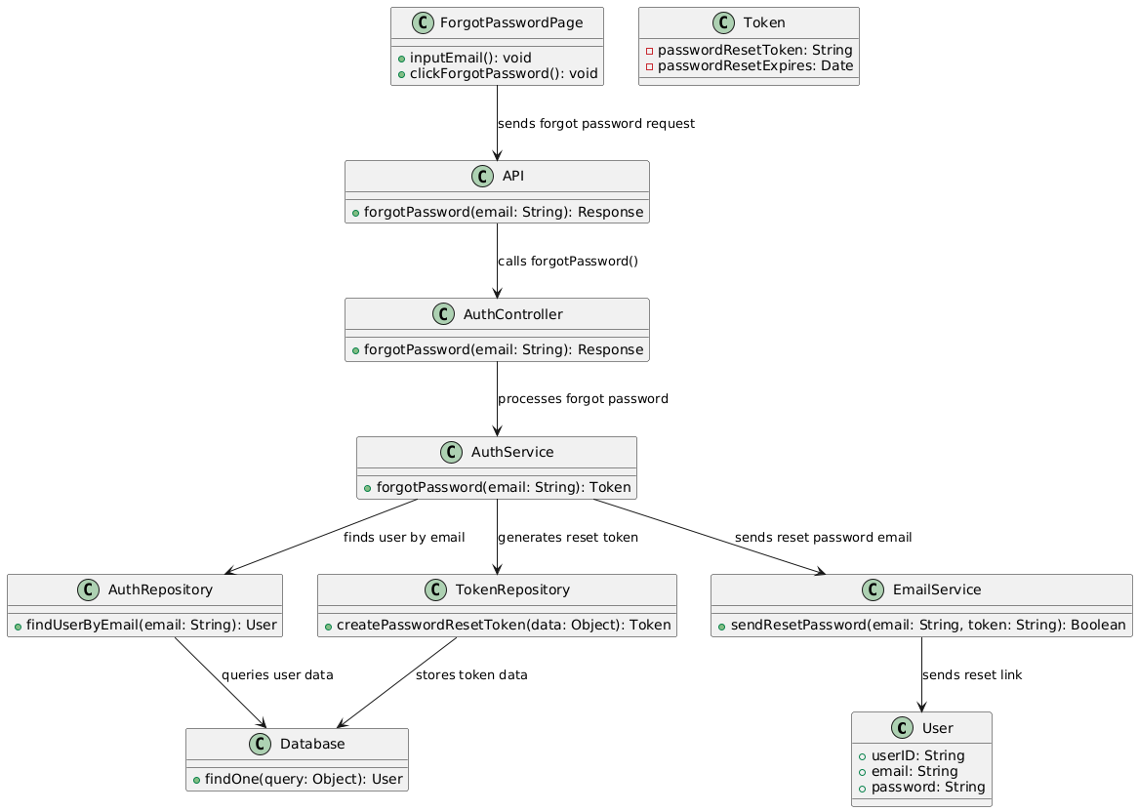
3.3.2 Sequence diagram
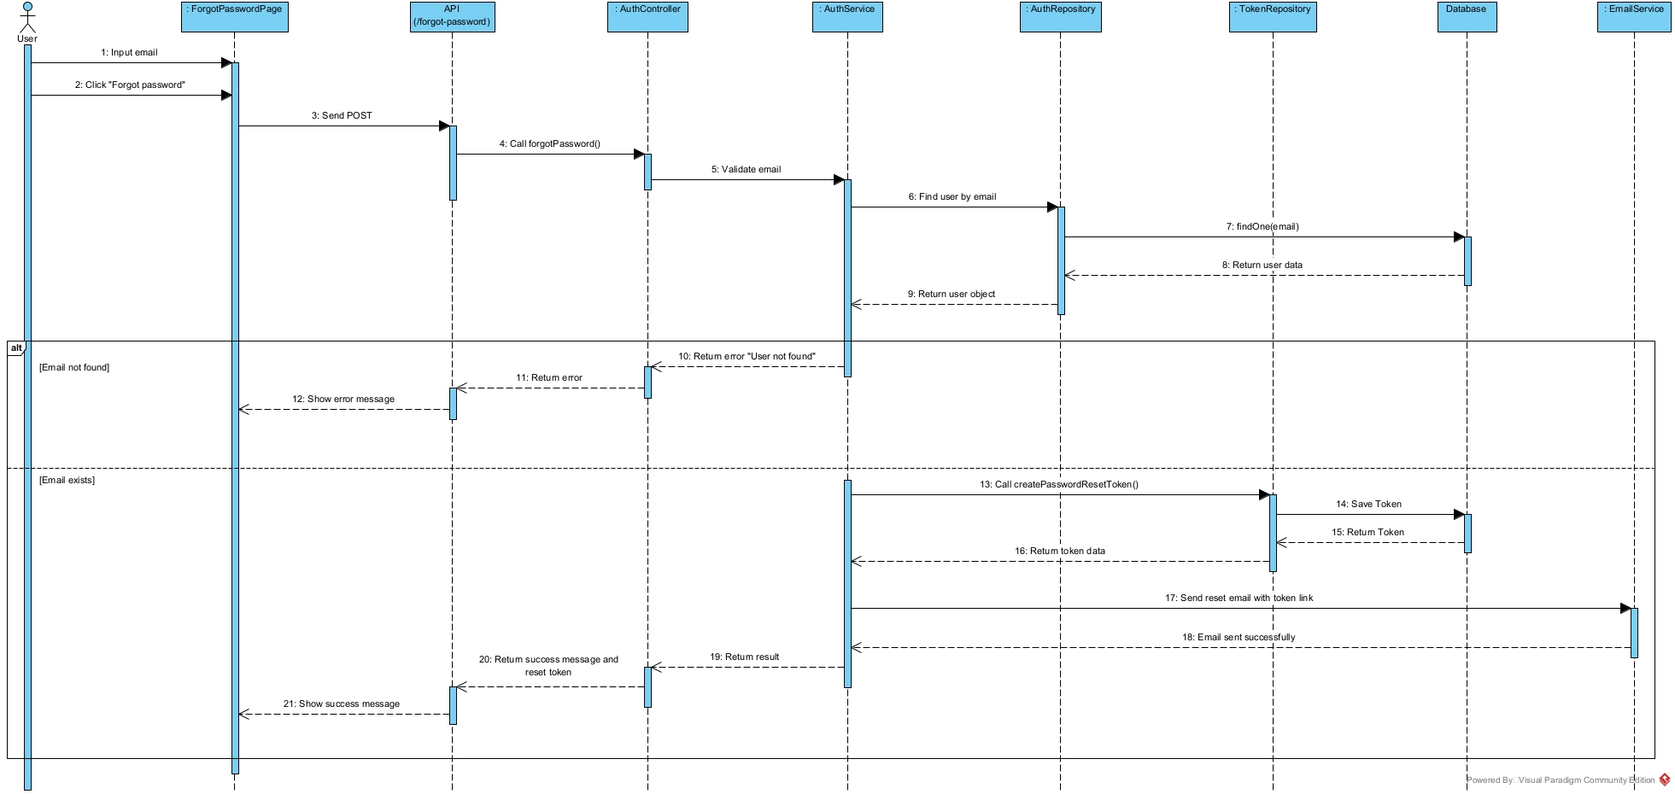

3.4 Create reservation (Bảo)
3.4.1 Class diagram
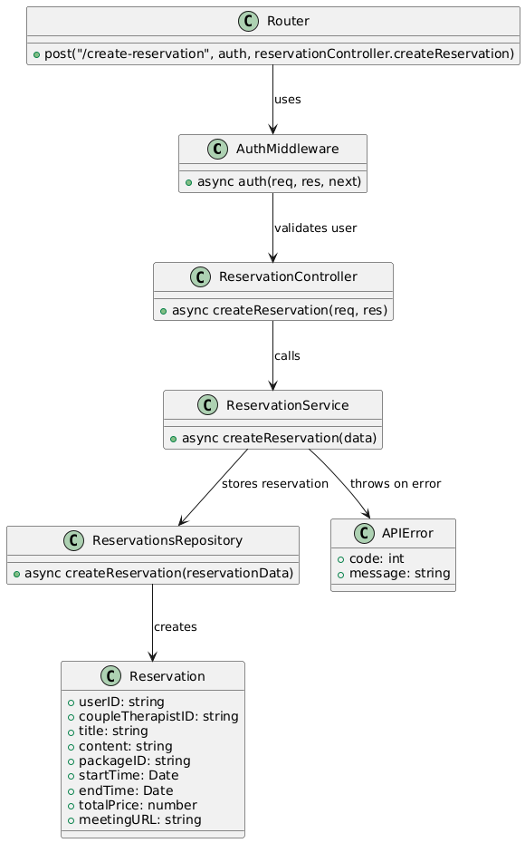
3.4.2 Sequence diagram
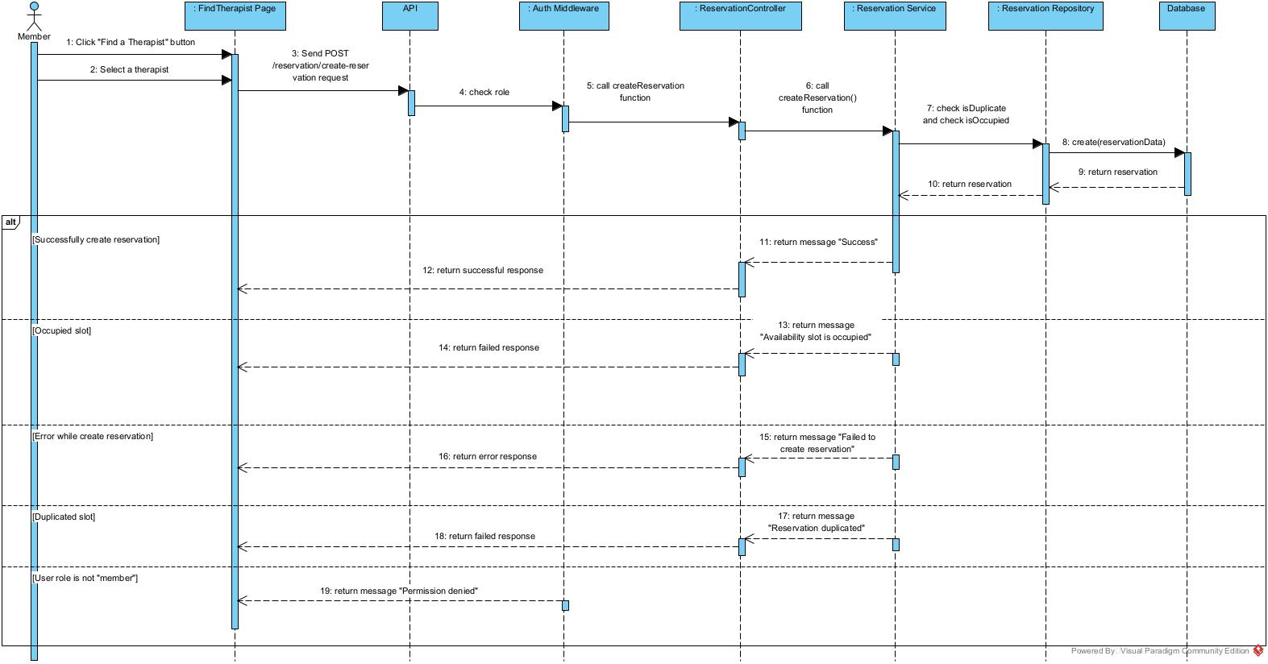

3.5 Update reservation (Bảo)
3.5.1 Class diagram
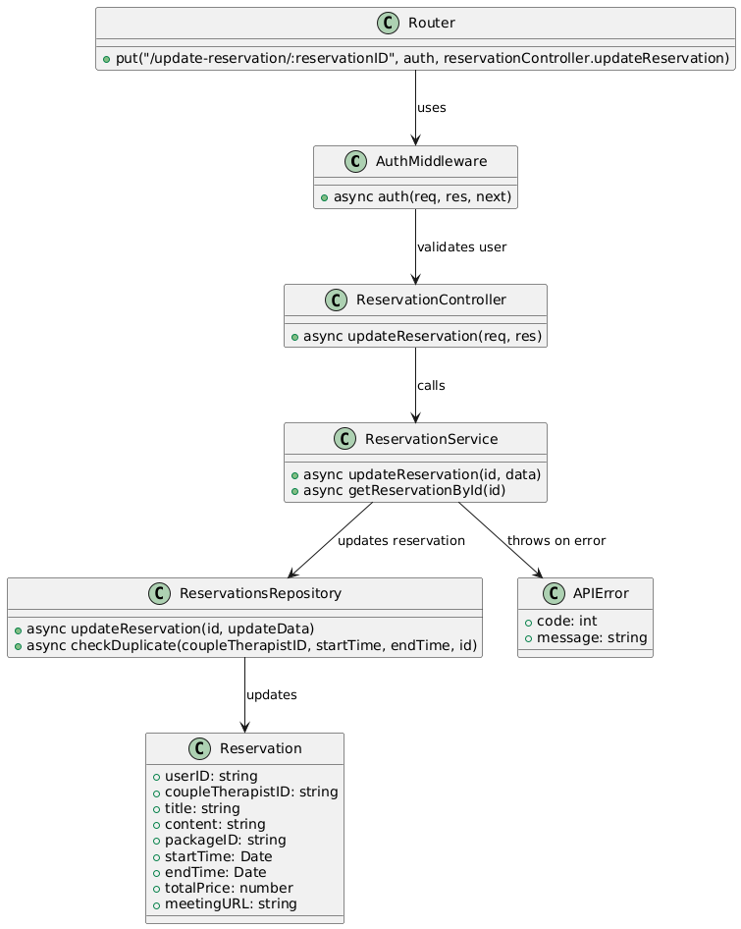
3.5.2 Sequence diagram


3.6 Cancel reservation (Bảo)
3.6.1 Class diagram
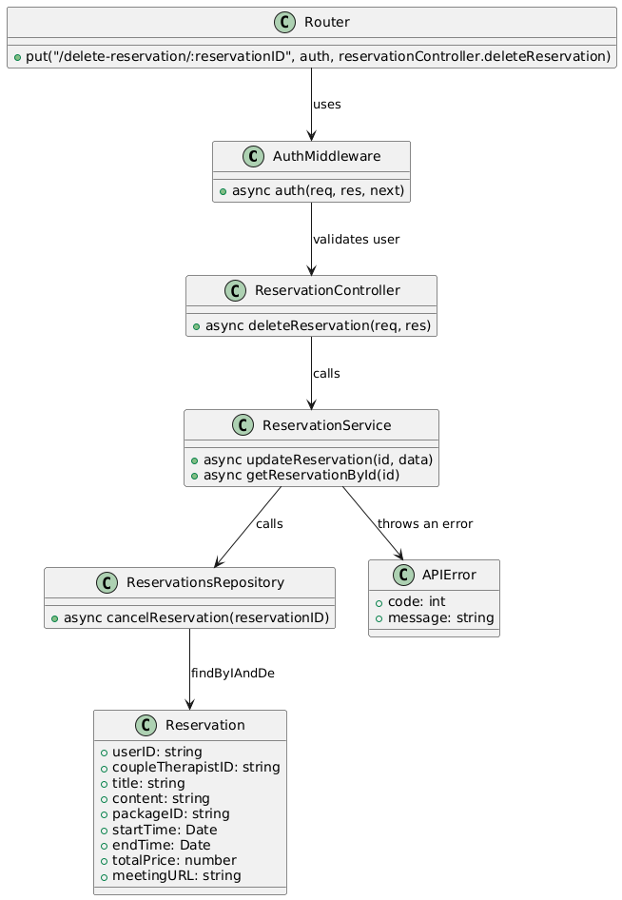
3.6.2 Sequence diagram
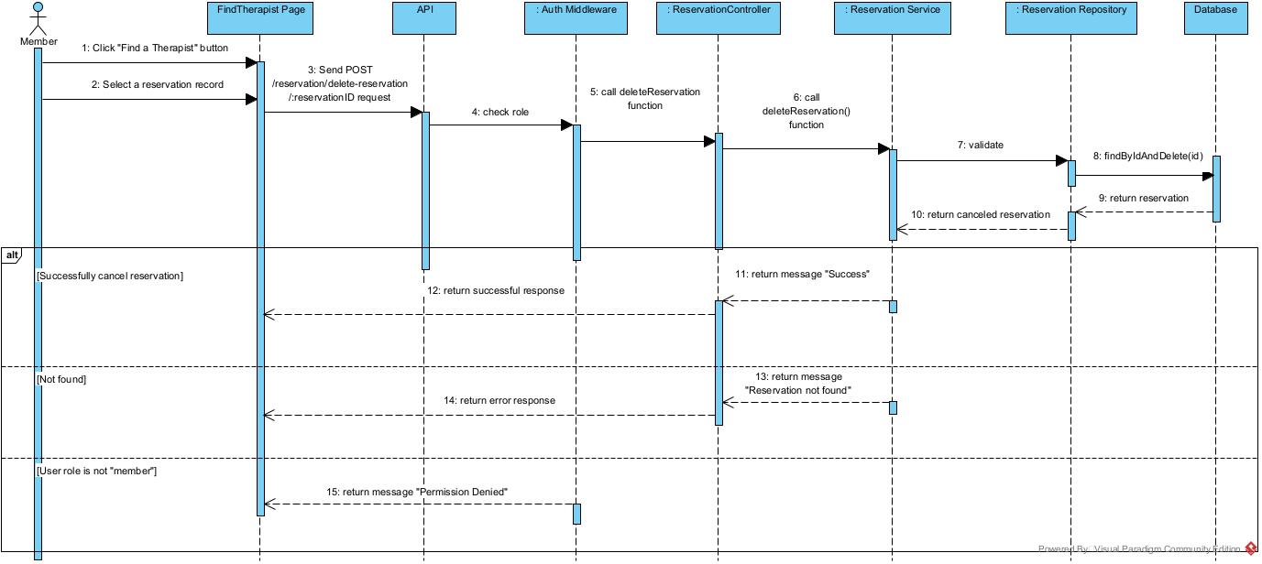

3.7 Create reservation result (Bảo)
3.7.1 Class diagram
3.7.2 Sequence diagram
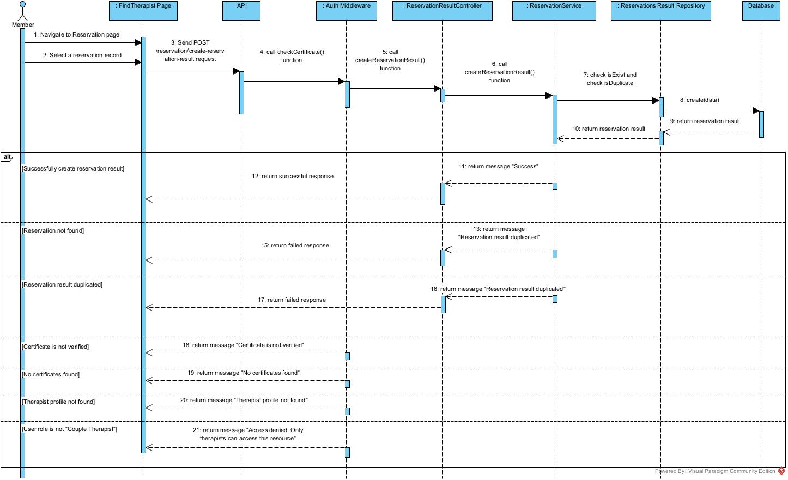

3.8 Update reservation result (Bảo)
3.8.1 Class diagram
3.8.2 Sequence diagram
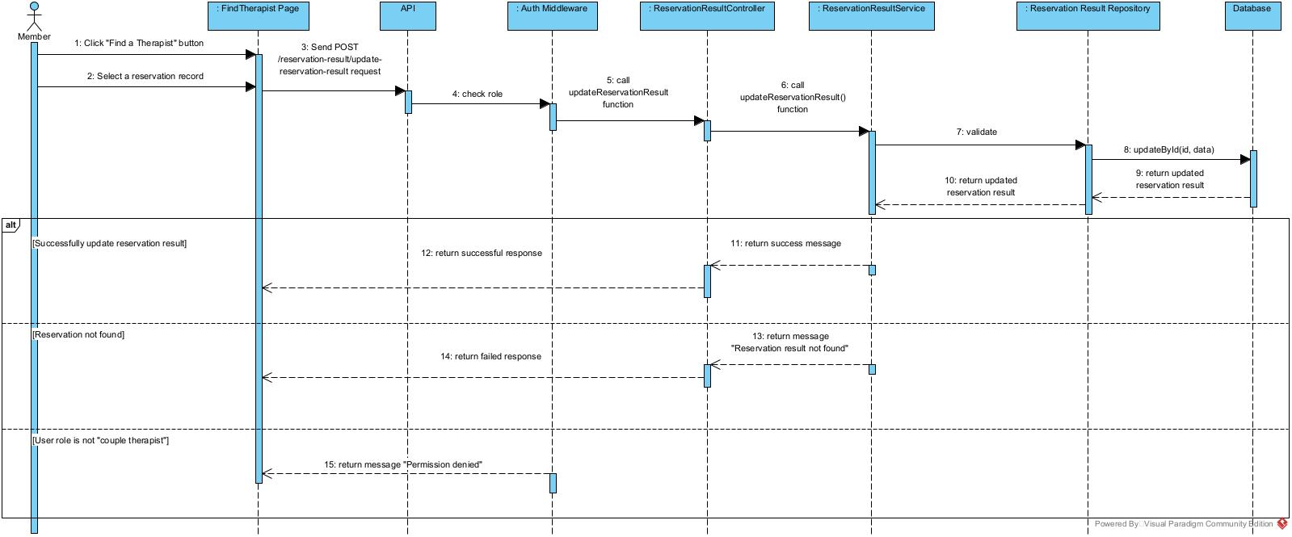

3.9 Delete reservation result (Bảo)
3.9.1 Class diagram
3.9.2 Sequence diagram
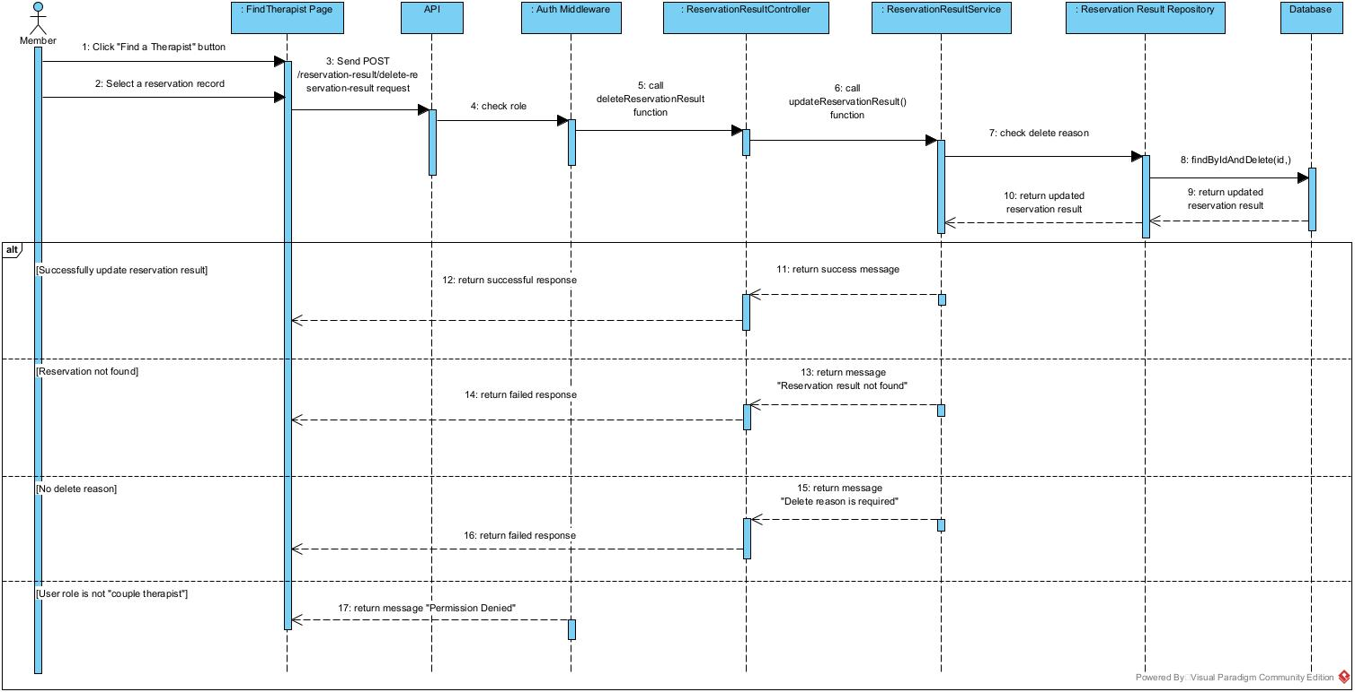

3.10 Approve reservation request (Bảo)
3.10.1 Class diagram
3.10.2 Sequence diagram
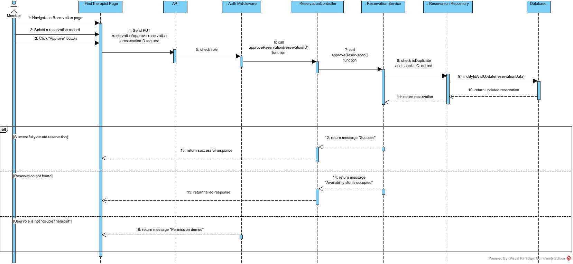

3.11 Deny reservation request (Bảo)
3.11.1 Class diagram
3.11.2 Sequence diagram
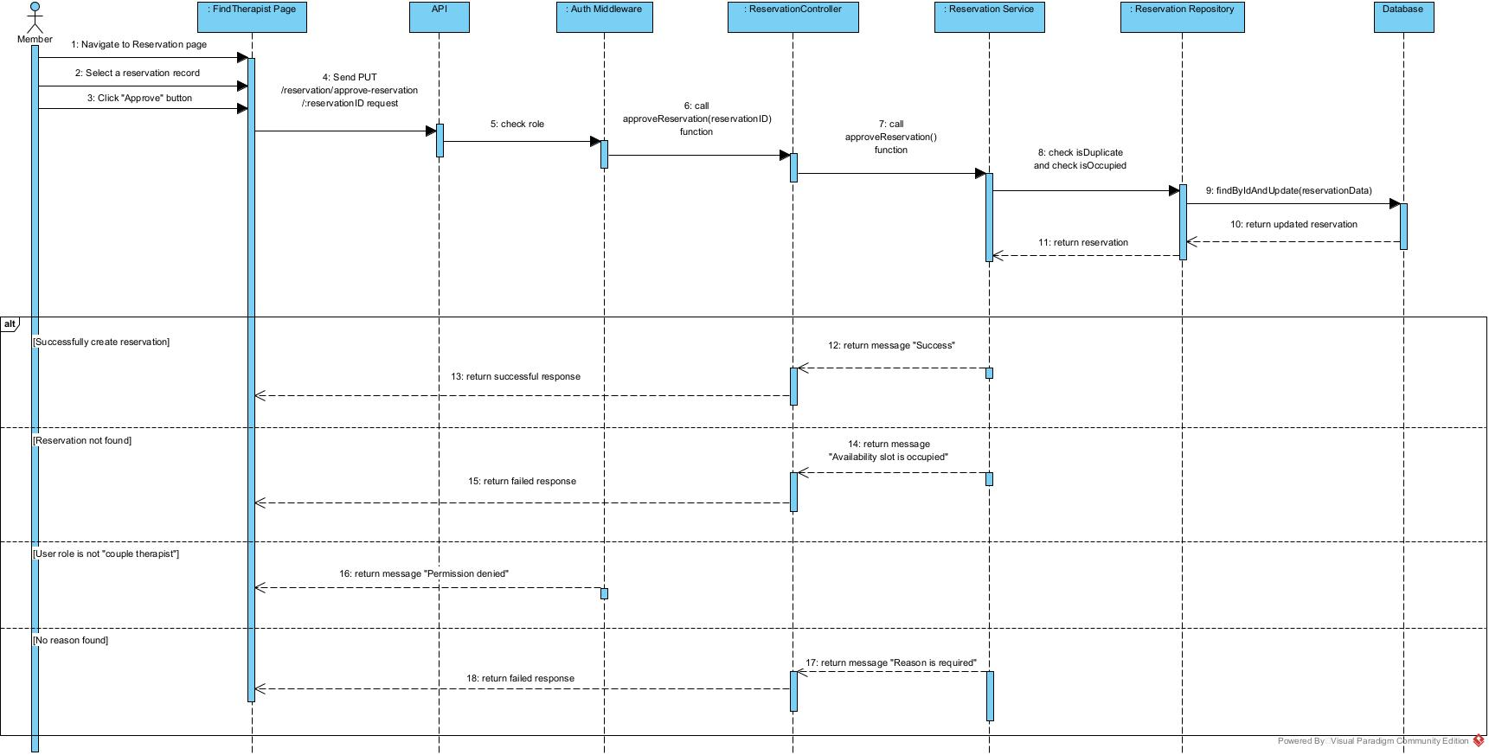

3.12 Change password (Nhật Long)
3.12.1 Class diagram
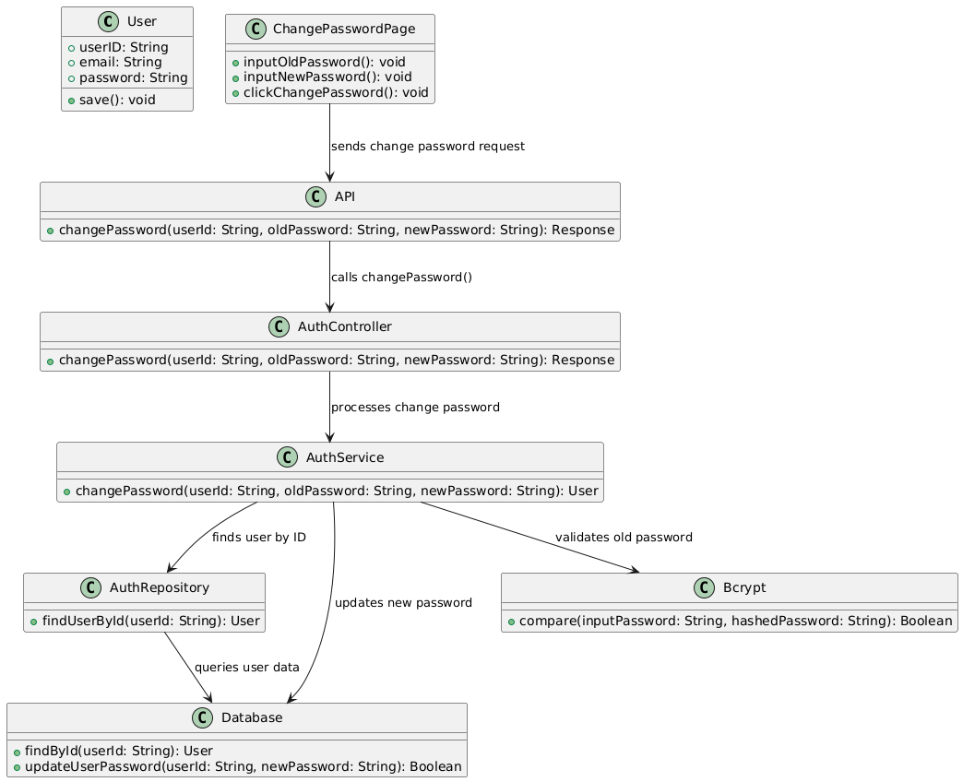
3.12.2 Sequence diagram
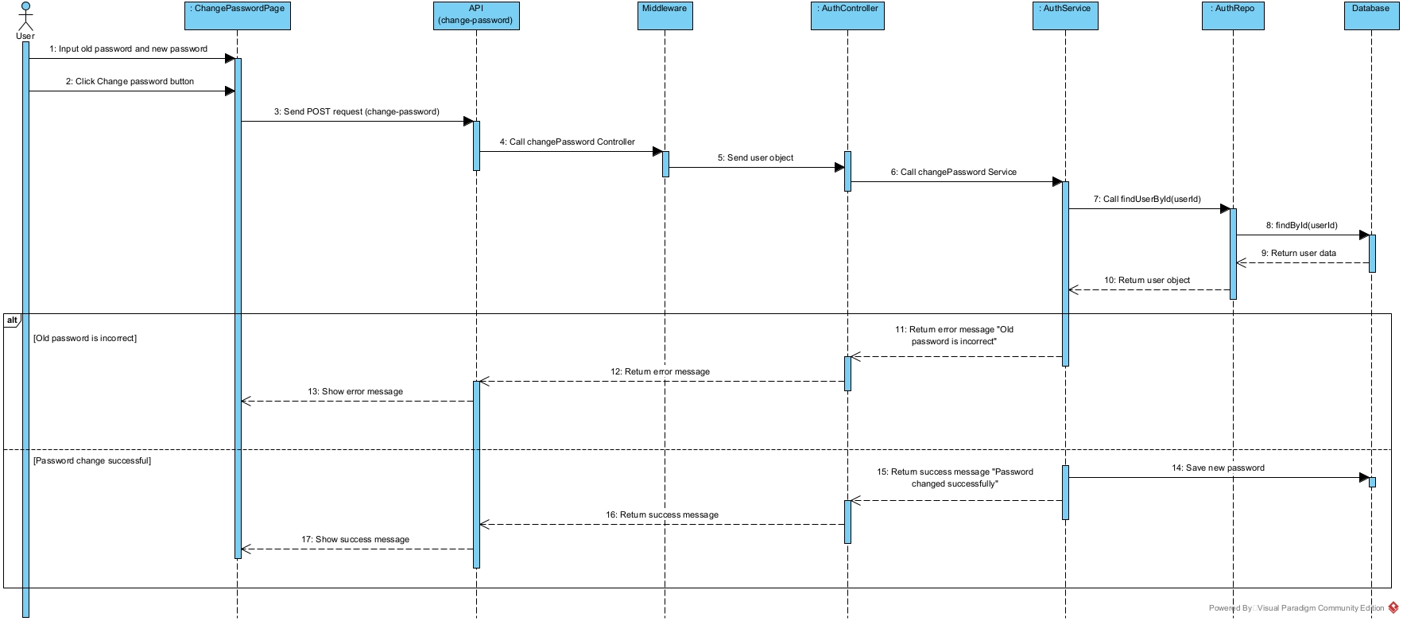

3.13 Do quiz (Hoàng Long)
3.13.1 Class diagram
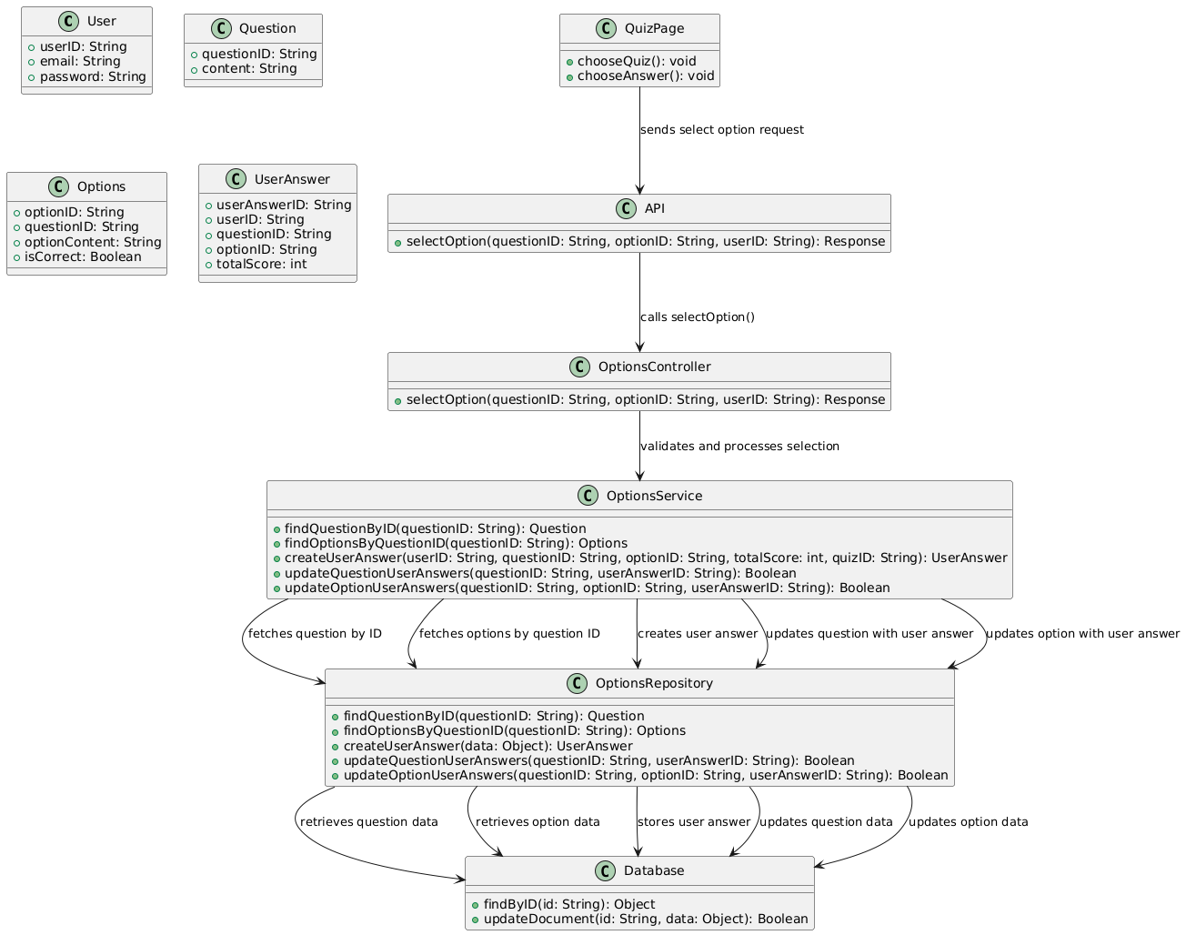
3.13.2 Sequence diagram
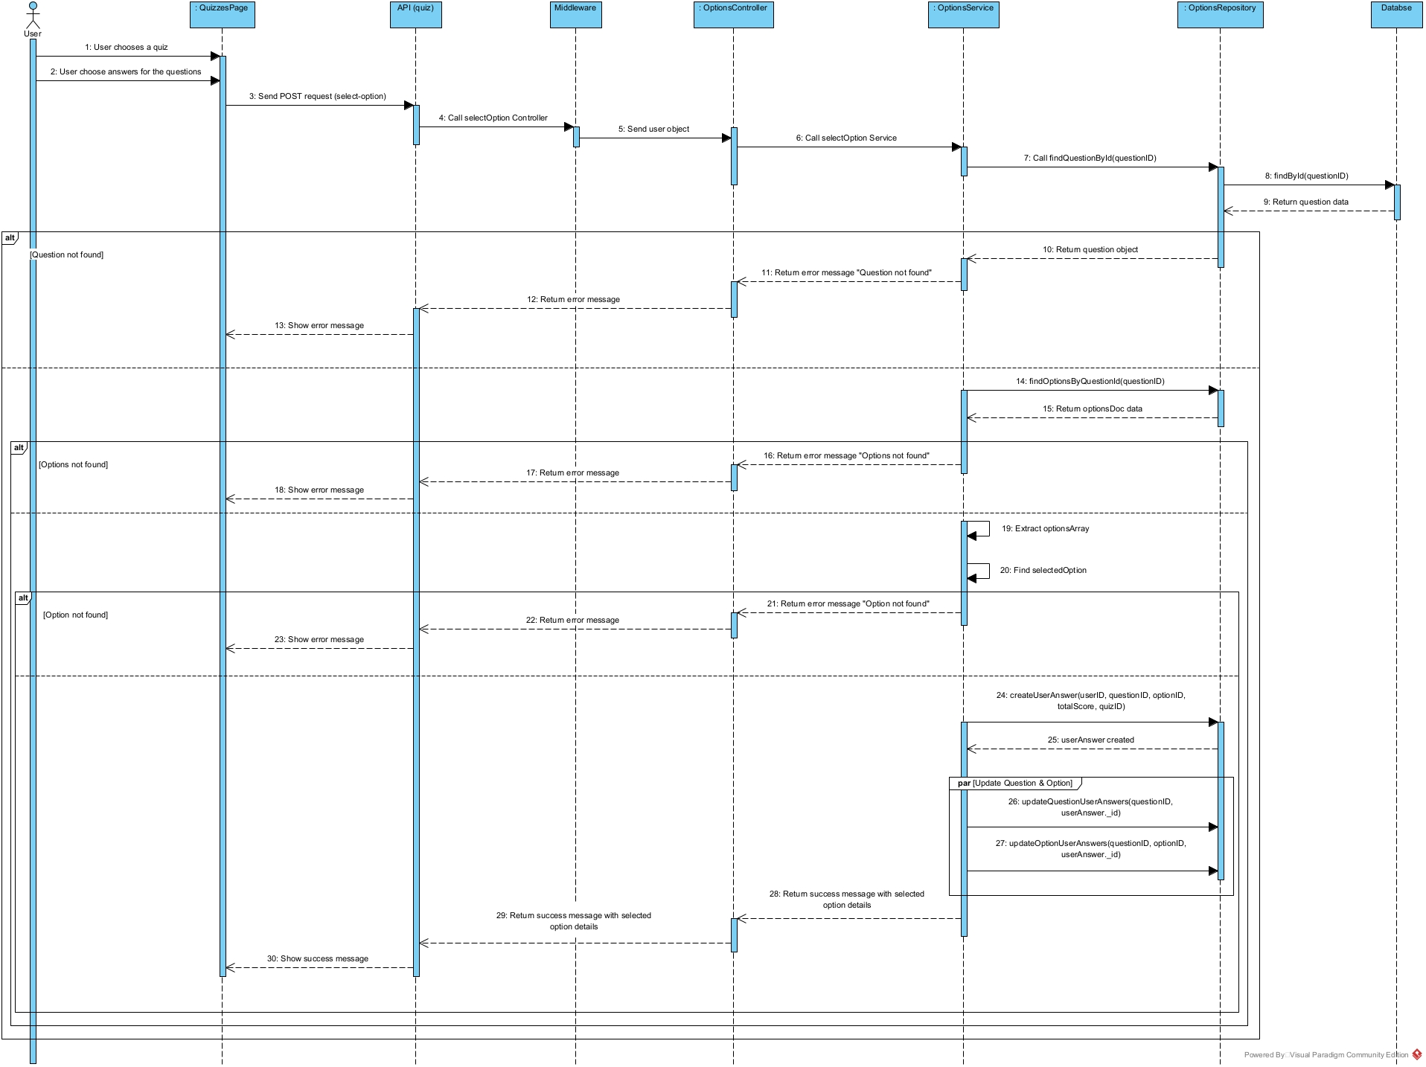

3.14 Manage profile (Nhật Long)
3.14.1 Class diagram
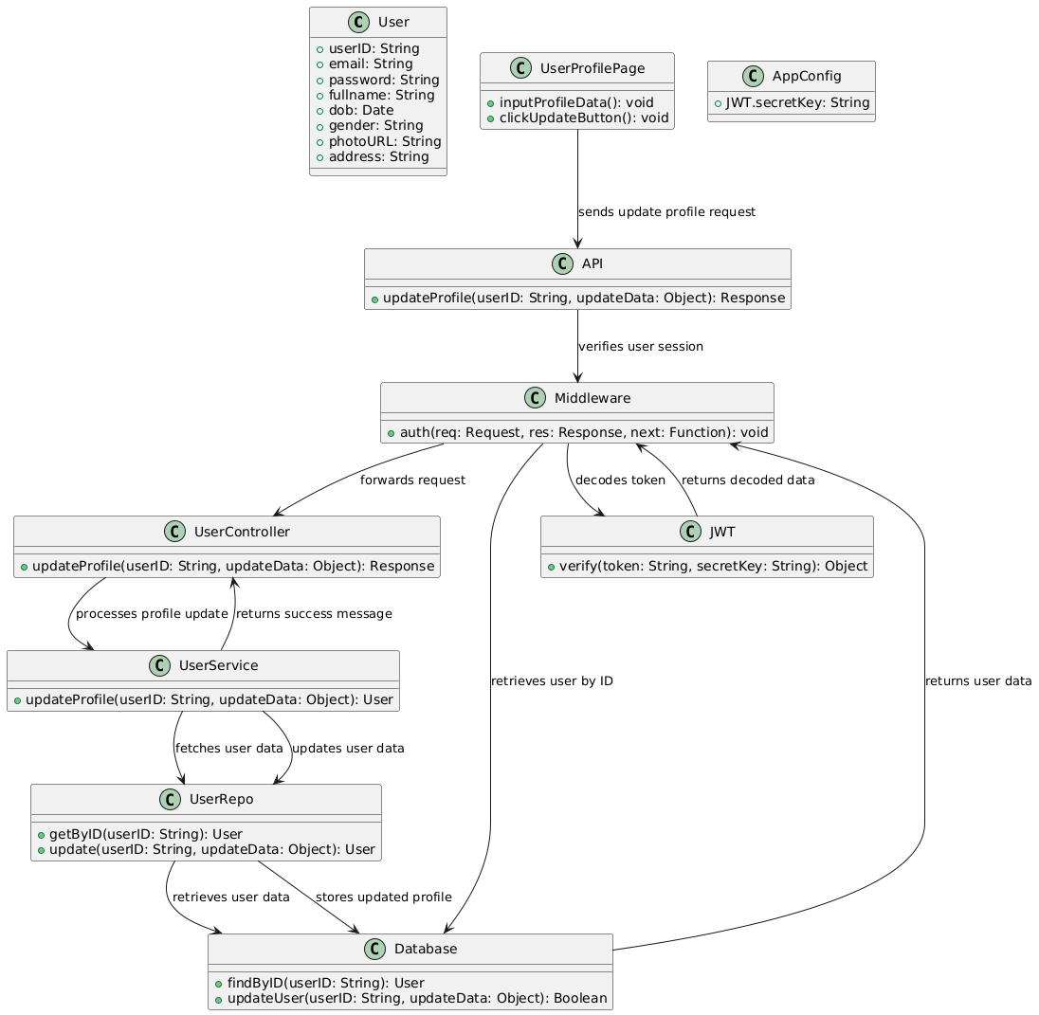
3.14.2 Sequence diagram
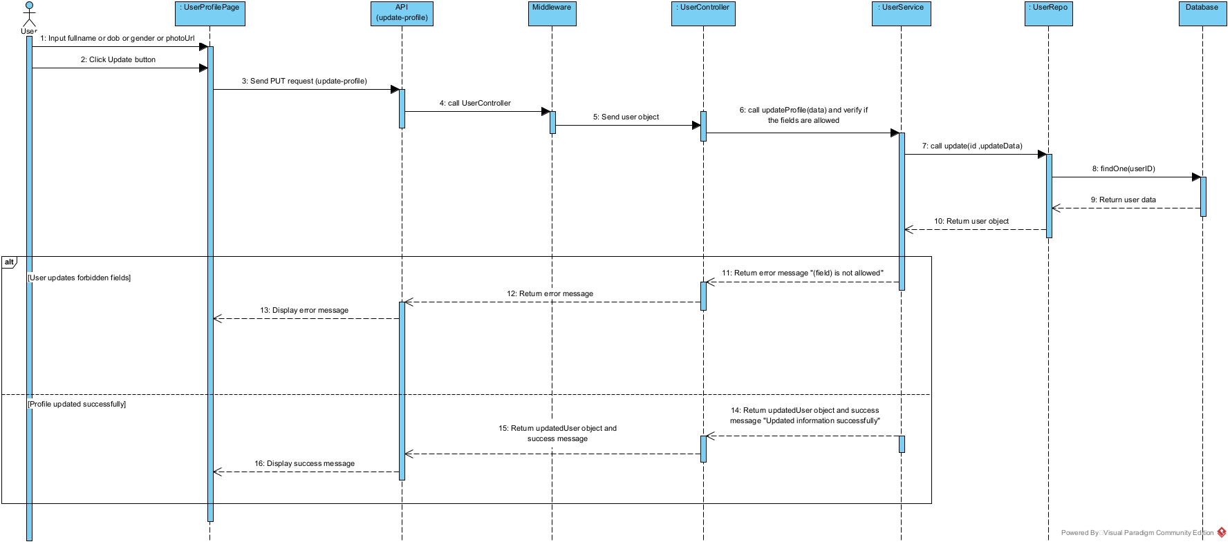

3.15 Search therapist (Vũ)
3.15.1 Class diagram
3.15.2 Sequence diagram
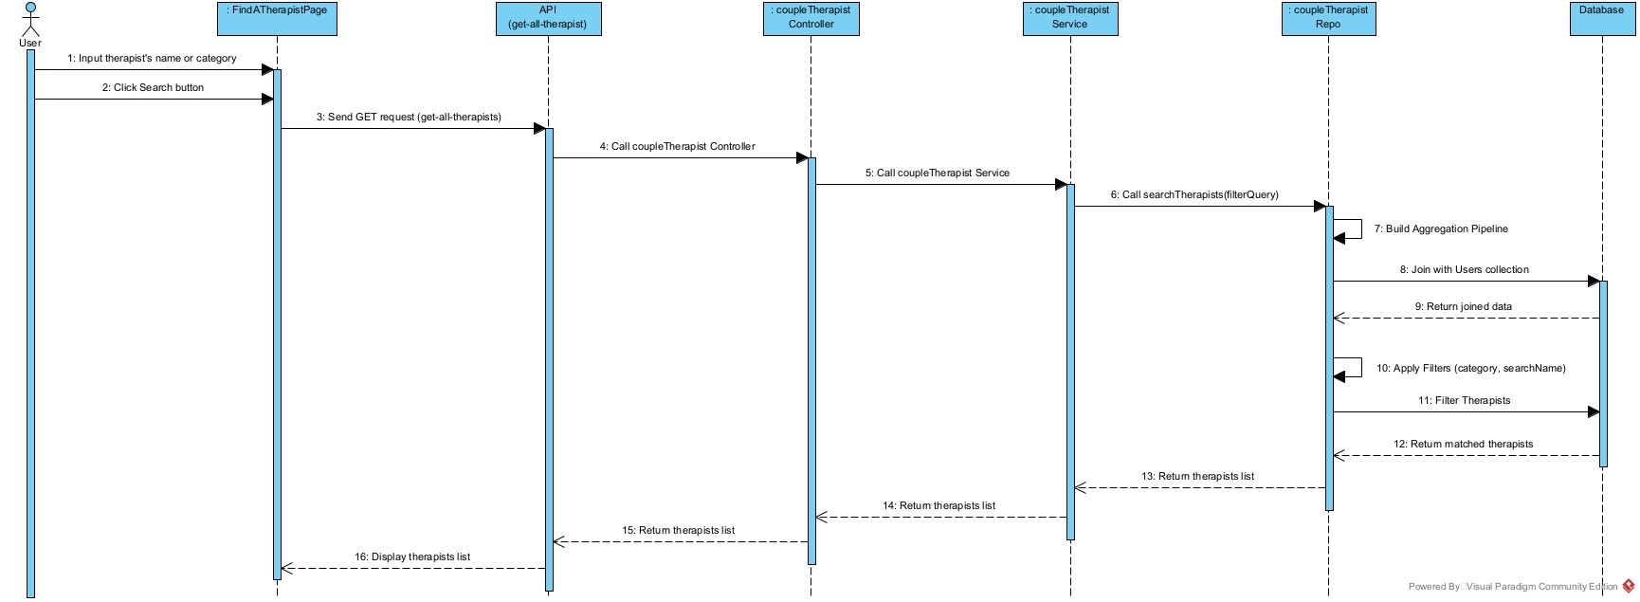

3.16 Manage rating and feedback (Vũ)
3.16.1 Class diagram
3.16.2 Sequence diagram
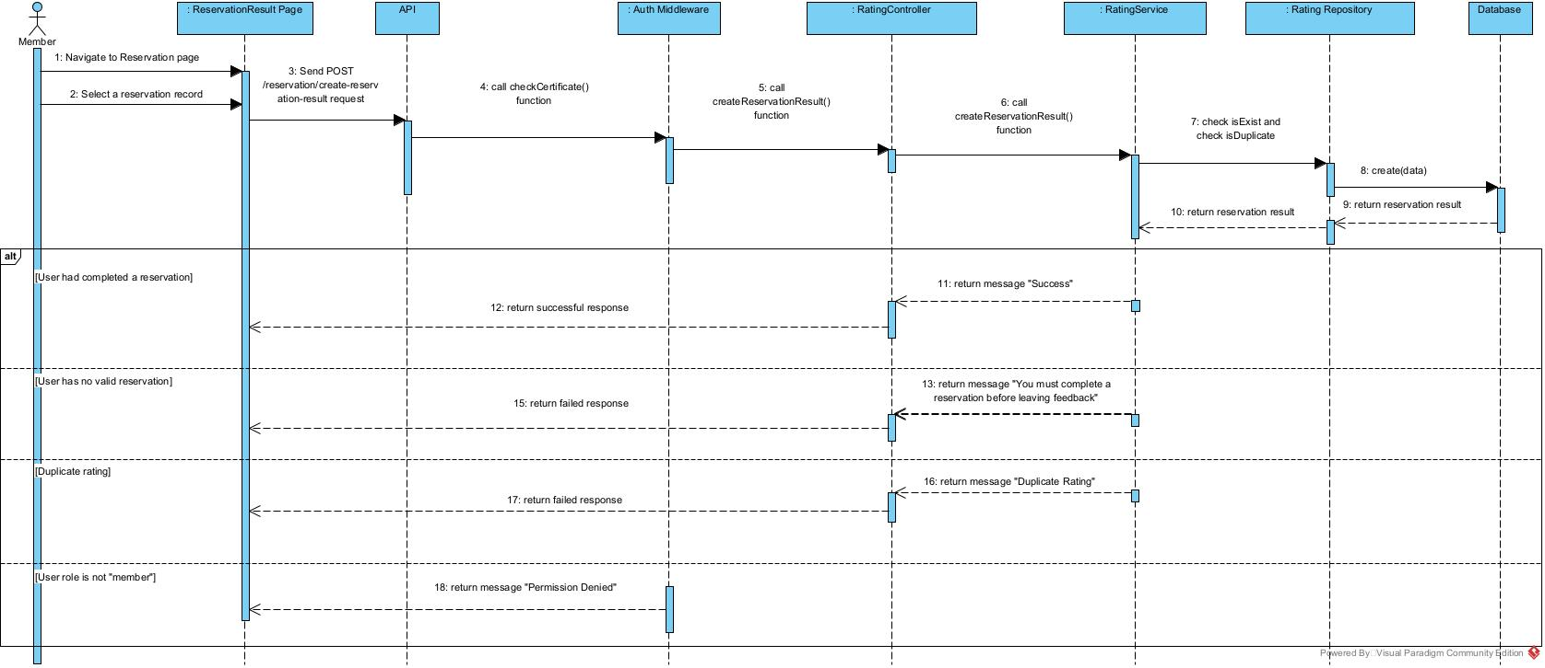

3.17 Manage certificates sent by Therapist (Hoàng Long)
3.17.1 Class diagram
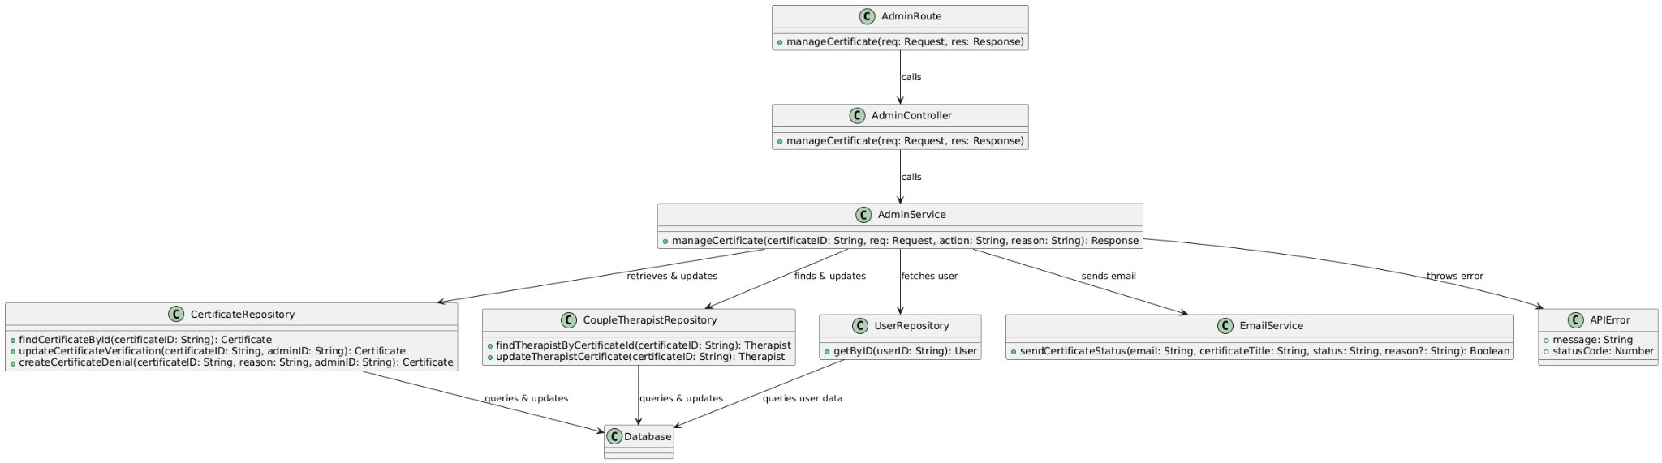
3.17.2 Sequence diagram
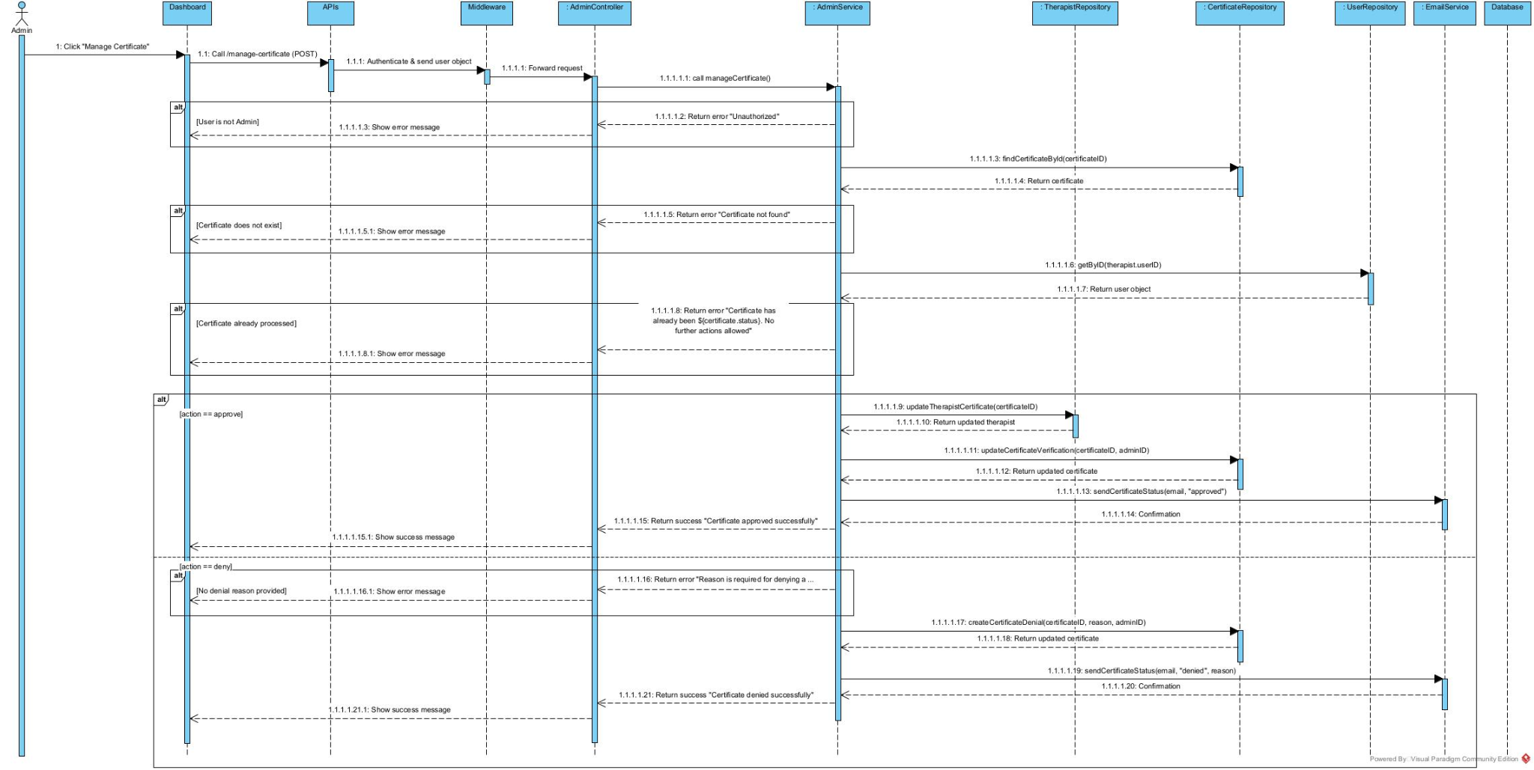

3.18 View Transactions (Vũ)
3.18.1 Class diagram
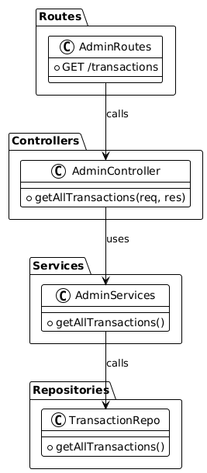
3.18.2 Sequence diagram
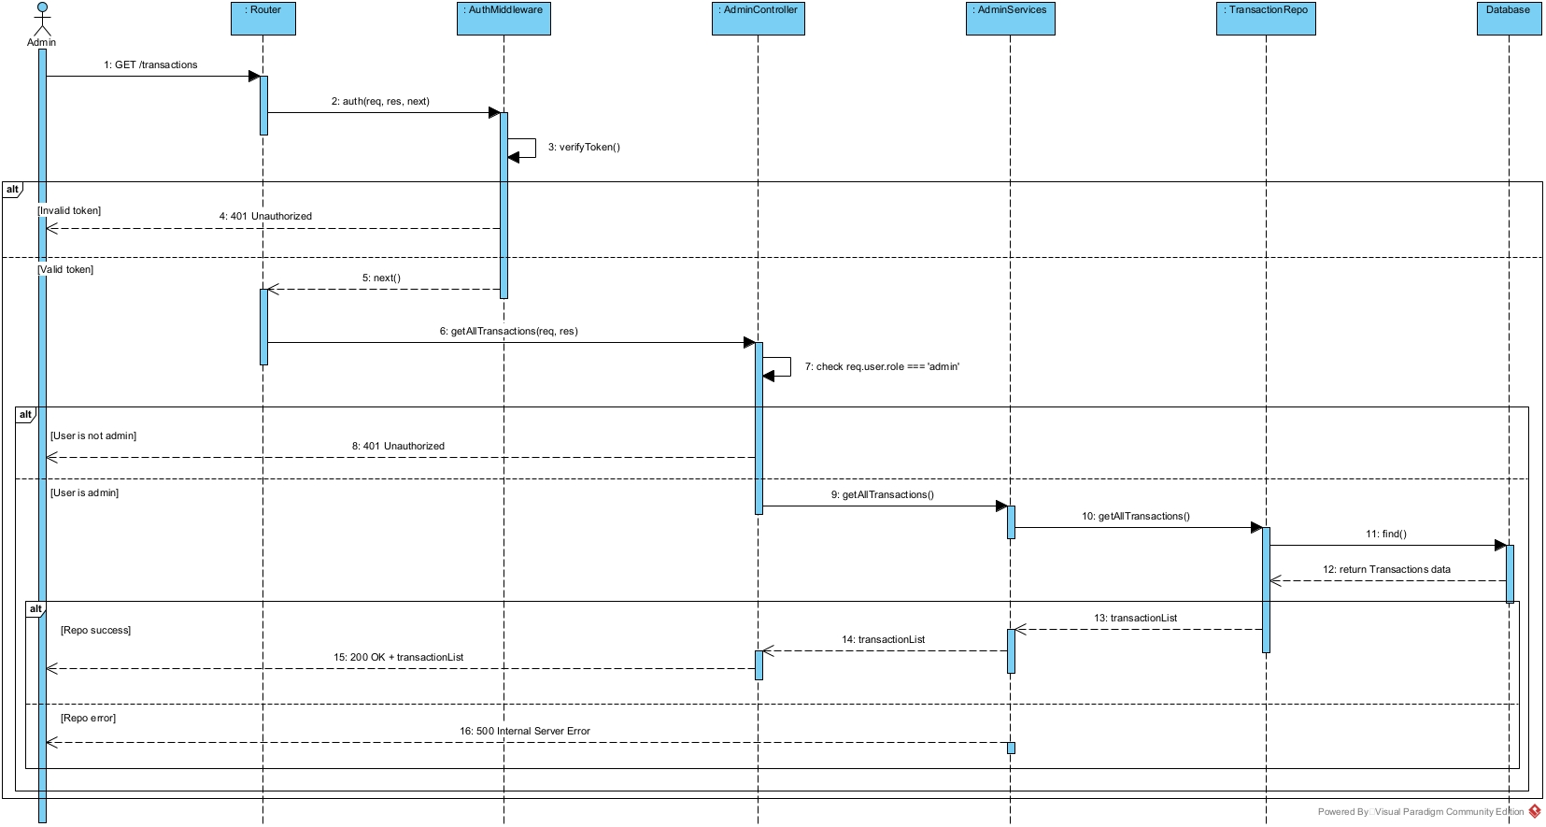

4. Activity Diagrams

4.1 Register (Vũ)
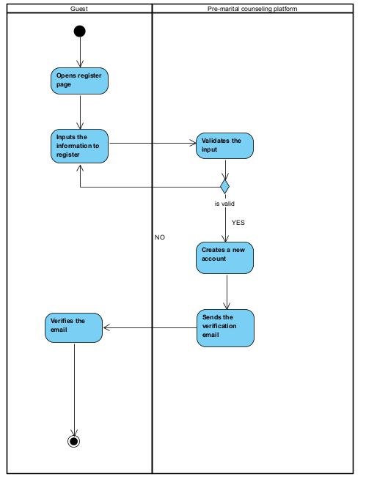

4.2 Login (Hoàng Long)
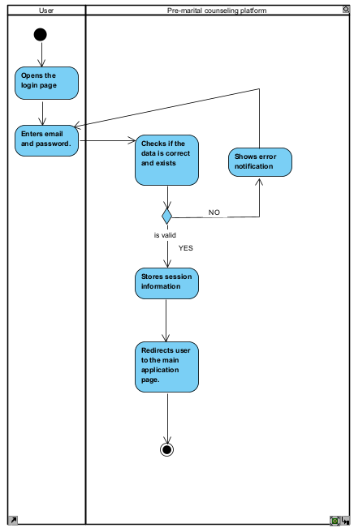

4.3 Make reservation (Nhật Long)
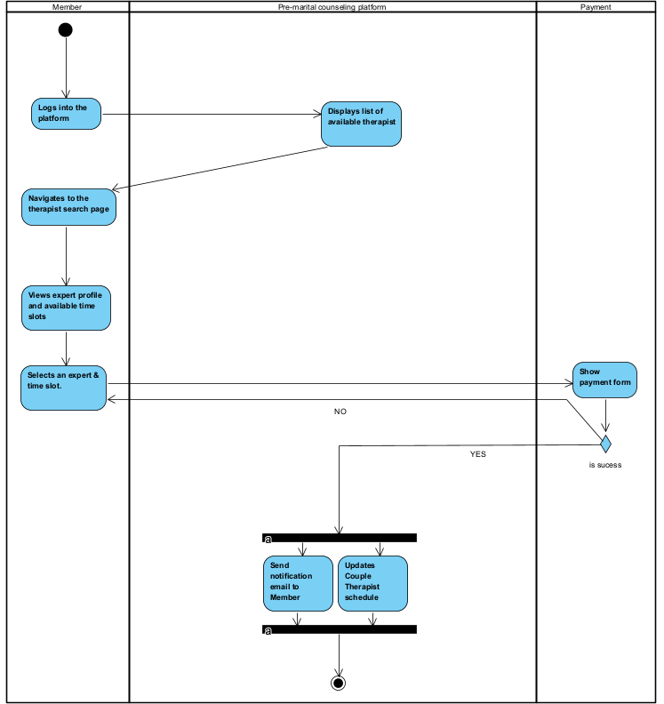

4.4 Do quiz (Nhật Long)
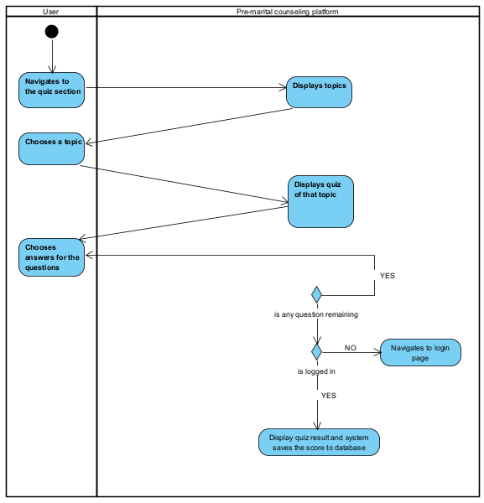

4.5 Conduct reservation and feedback (Vũ)
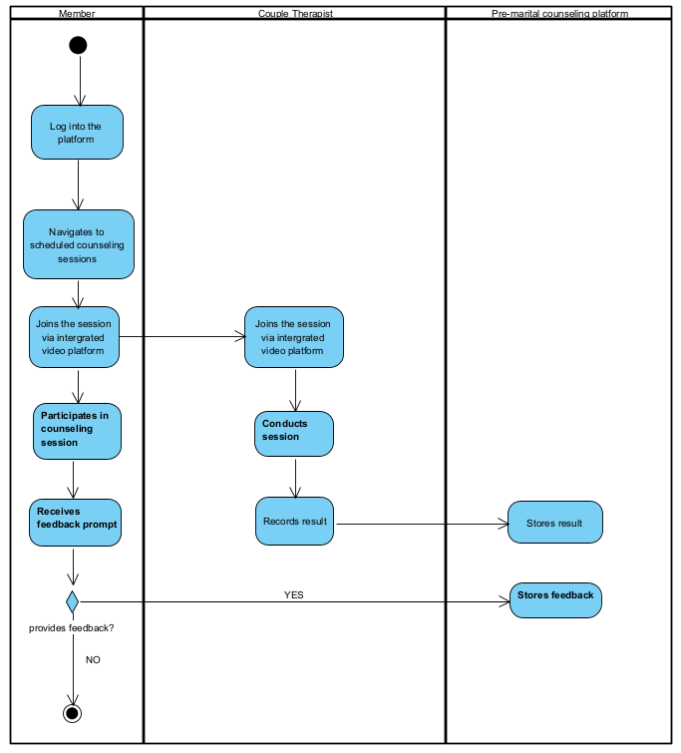

4.6 Certificate approval (Vũ)
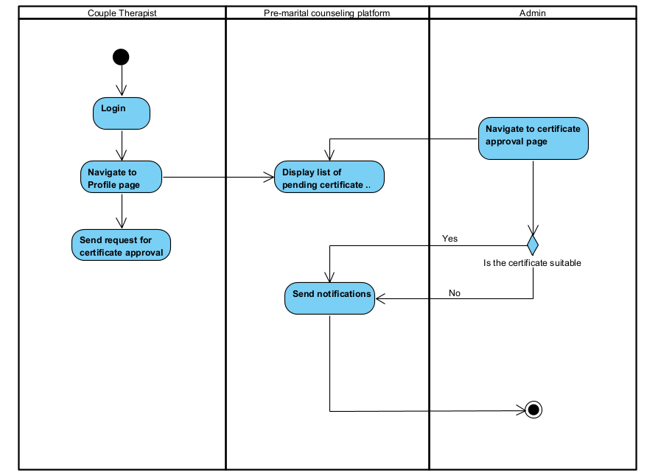

5. State Diagrams

5.1 Reservation (Vũ)
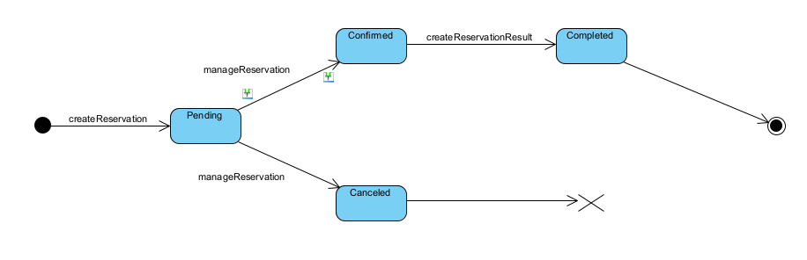

5.2 Option (Nhật Long)
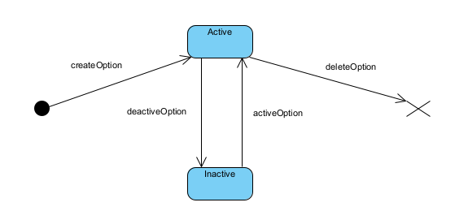

5.3 Question Bank (Vũ, Hoàng Long)
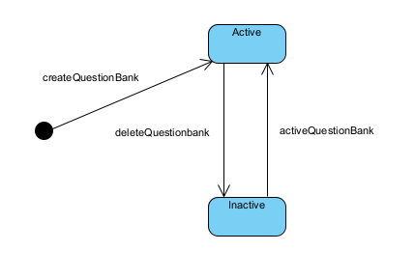

5.4 Topic (Vũ)
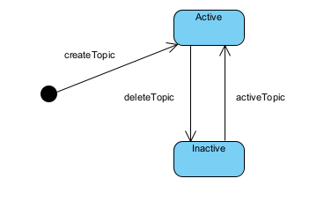

5.5 Certificate (Vũ)
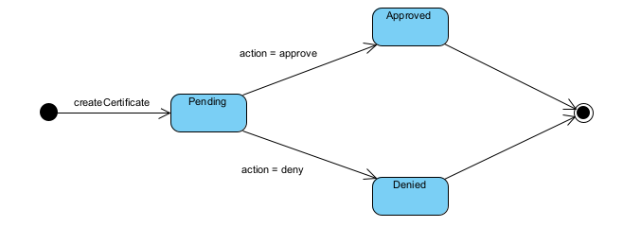

5.6 Question (Vũ, Hoàng Long)
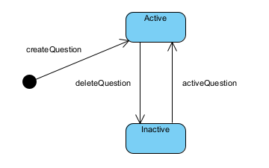

5.7 Payment (Vũ, Hoàng Long)
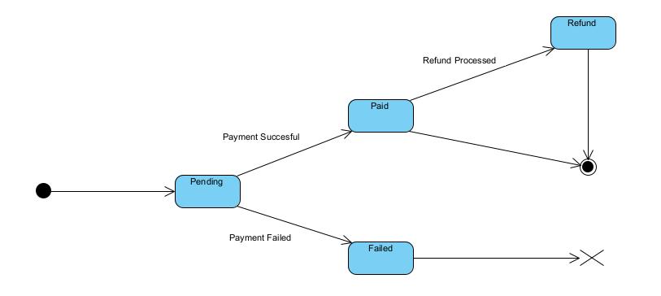
5.8 Package (Vũ, Hoàng Long)
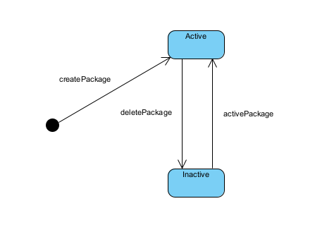

V. Software Testing Documentation
[Provide final software testing information follow the template as part II in the Report #5]

1. Scope of Testing
[Describe the scopes of the test. Those include the target-of-test’s features, functions, and non-functional requirements that will or will not be tested.
Describe the stages/levels of testing that would be applied to your project­ - Unit, Integration, or System test. Each includes the in-charge, inputs/time, focuses, acceptance criteria.
List any constraints or assumptions made during the development of this document that may impact the design, development or implementation of testing]

2. Test Strategy
[List out and describe all testing types (you can refer the test types listed below or any other test types to selected the suitable ones for the project; for each selected test types you need to provide the following information: test objective, technique, completion criteria, etc.), test levels that those test types would be performed, & the details of test supporting tools would be used in the project]

2.1 Testing Types
[List out and describe here the testing types which you would apply in your project. You need to mention following information for each type of testing: objective, technique, completion criteria]

2.2 Test Levels
<List out and describe here the testing levels which you would execute in your project. Besides, clearly state the test types which are performed in each test level that you plan for this project>

2.3 Supporting Tools
<List of the test supporting tools which will be employed for this project>

3. Test Plan

3.1 Human Resources
[List and provide the details on roles and responsibilities of the project members who would involve in testing works]

3.2 Test Environment
[List and provide the details about the tools (software, hardware, infrastructure) which the project would use for testing]

3.3 Test Milestones
[Separate test milestones, which should be identified to communicate project status accomplishments]

4. Test Cases
[Prepare the details on the test cases following the provided template
· Unit Test Cases: Report5_Unit Test.xls
· Other Test Cases (IT, ST, AT): Report5_Test Report.xls]

5. Test Reports
[Provide the test result, statistics and the relevant test analysis for your testing in the project]

VI. Release Package & User Guides
[Provide final software testing information follow the template as part II in the Report #6]

1. Deliverable Package
[The section will list all source programs, scripts, documents with version number in this release. You can see the example following table for reference, can customize or delete if not using belong to each project characteristics]
No. | Deliverable Item | Description
1 | Schedule/Task Tracking
2 | Project Backlog
3 | Source Codes
4 | Database Script(s)
5 | Final Report Document
6 | Test Cases Document
7 | Defects List
8 | Issues List
9 | Slide

2. Installation Guides

2.1 System Requirements
[Define any system requirements necessary to support the application, including the software and relevant configurations]

2.2 Installation Instruction
[Includes installation instructions and configuration guidelines]

3. User Manual

3.1 Overview
[Descript the overview of the application and if could, insert the features workflow to help user has the overview of all the features in this application]

3.2 Workflow 1
[Describe the purpose of this workflow, draw workflow diagram and other relevant diagrams]
[Describe the detailed guides for the workflow by providing the brief description, step by step guides (attached with user interface) of how to use that function]

3.3 Workflow 2
…

